INTELLICASH
VSLA Digitisation Platform
─────────────────────────────────────────────────────
System Design Document
VERSION 1.0 · MASTER AUTHORISED RELEASE
The definitive technical specification for the design, build, and deployment of Intellicash
─────────────────────────────────────────────────────
Developed & Owned by: Intelli-Wealth Limited (IWL)
FLOURISH VSLA Programme · Agreement SF 00112775
Nairobi, Kenya · May 2026

Attribute | Value
Document Title | Intellicash — System Design Document
Version | 1.0 (Master Authorised Release)
Status | APPROVED — Primary Technical Authority
Classification | CONFIDENTIAL — IWL Internal & Authorised Partners Only
Replaces | All prior draft versions, wireframe documents, and partial specifications
Programme | FLOURISH VSLA Programme · Agreement SF 00112775
Platform | intellicash.co.ke
Date Authorised | May 2026
Document Owner | Executive Director, Intelli-Wealth Limited
Version Control | All amendments require Executive Director sign-off and increment of document version

This document is the single authorised source of truth for Intellicash system design. All development, testing, partner integration, and deployment decisions must reference this document. No feature may be built that is absent from this specification, and no feature specified herein may be omitted from the production system, without a formal version amendment approved by IWL Executive Director.

Table of Contents
Table of Contents 2
1.1 Platform Vision 4
1.2 Platform Mission 4
1.3 Strategic Context 4
1.4 Design Principles 5
2.1 Tri-Account Onboarding Model 7
2.2 Member Account Personas 7
2.3 Group Account Personas 9
2.4 Agent Account Personas 9
4.1 Architecture Overview 19
4.2 Architecture Layers 20
4.3 Two-Product Architecture 20
5.1 Navigation Structure 22
5.2 IWL 8-Step Meeting Workflow 22
5.3 CBT / Village Agent Module 23
5.4 Share-Out Wizard 24
6.1 Service Architecture Diagram 26
6.2 Service Specifications 26
7.1 Identity & Account Domain 31
7.2 Meeting & OTP Domain 34
7.3 Loan & Credit Guarantee Domain 36
7.4 External Finance Domain 39
7.5 Governance Domain 41
8.1 Hyperledger Fabric Network Configuration 45
8.2 Chaincode Domains 46
8.3 On-Chain vs. Off-Chain Data Policy 46
9.1 IWL Five-Layer Anti-Manipulation Framework 48
9.2 System-Enforced Separation of Duties 48
9.3 Data Protection & KDPA 2019 Compliance 49
10.1 Payment Transaction Map 51
10.2 IWL Paybill — Custodian Account 52
10.3 Paystack Integration — IWL Direct Loans 53
10.4 External Integrations 53
11.1 Onboarding — Account Type Selection 55
11.2 Group Account — OTP Meeting Activation 55
11.3 Member Account — Personal Dashboard 56
11.4 Group Account — External & IWL Loans Panel 57
11.5 Group Account — Paybill Savings Screen 58
11.6 Member Account — Credit Guarantee Request 59
11.7 Agent Account — CBT Caseload Dashboard 59
11.8 Web Platform — Partner Portfolio Dashboard 60
12.1 IWL Credit Score Algorithm 61
12.2 External Loan Pipeline (Web Platform) 62
12.3 VSLA Federation (VSLF) 62
14.1 Groups & Portfolio Endpoints 69
14.2 MEL & Reporting Endpoints 70
14.3 Webhook Events 70
16.1 Web Platform Module Map 74

SECTION 1
Vision, Mission & Strategic Context
Why Intellicash exists and what it must achieve

1.1 Platform Vision
To be the most trusted digital infrastructure for grassroots savings and credit in Africa — making every shilling saved by every VSLA member fully transparent, secure, and connected to the formal financial system.

1.2 Platform Mission
Intellicash exists to digitise the complete lifecycle of a Village Savings & Loan Association (VSLA) — replacing the physical cashbox, paper passbooks, and verbal group votes with a secure, transparent, offline-capable digital system that preserves and enforces the IWL Savings Group Standard (IWLSGS) methodology at every step.

The platform must simultaneously serve:
- VSLA members — enabling transparent personal financial records, dignified loan access, and democratic participation
- Group officers and key-holders — enforcing fiduciary duty, procedural integrity, and collective governance
- Village Agents / CBTs — making field facilitation measurable, auditable, and scalable
- Partner organisations (NGOs, MFIs, banks, government) — providing real-time portfolio intelligence without compromising group sovereignty
- Intelli-Wealth Limited — advancing financial inclusion, generating programme evidence, and building a sustainable social enterprise

1.3 Strategic Context
The VSLA model is one of the most proven financial inclusion tools in Sub-Saharan Africa, with over 14 million members across the continent. Yet the model remains largely paper-based, vulnerable to fraud, invisible to formal finance, and difficult to monitor at scale. Intellicash is IWL's answer to these structural limitations.

Strategic Challenge | Intellicash Response
Physical cashbox risk: single-point fraud by treasurer or officer | Three-Key OTP system: no meeting opens without all three key-holders physically present and digitally verified
Paper passbooks: easily falsified, lost, or manipulated | Append-only blockchain-backed digital passbook: cryptographically immutable, permanently auditable
Groups invisible to formal finance: no credit history | IWL Credit Score: machine-computed from live group data; credentialing groups for bank and MFI access
Groups without bank accounts excluded from formal credit | IWL Custodian Paybill: groups save into IWL-managed sub-accounts via M-Pesa, enabling formal-equivalent credit access
Members unable to guarantee each other's loans formally | Credit Guarantee System: blockchain-recorded guarantor commitments with automatic liability calling on default
Donors and partners flying blind on programme impact | Real-time MEL dashboard and API: live data on 47 indicators across all programme groups
VA field work unaccountable and difficult to quality-assure | CBT Module: GPS-stamped structured visit logs, quality scoring, phase gating — all on a single mobile app
External loans inaccessible to most VSLAs | External Loan Module: direct integration with KCB, Equity, and AMREF MFI; IWL Direct Loans via Paystack

1.4 Design Principles
These principles are non-negotiable. Any feature that conflicts with a design principle must be redesigned, not the principle relaxed.

Principle | Statement | Implication for Developers
Methodology-First | Every screen, workflow, and data field must map to a documented IWLSGS procedure | No feature may be added that bypasses or contradicts IWL's VSLA methodology
Offline-First | Full meeting functionality — all 8 steps — must work without internet connectivity | All financial logic must run on-device; server sync is secondary, not blocking
Blockchain-Immutable | Every financial transaction must produce an immutable blockchain record | No DELETE or UPDATE ever permitted on any financial record in any database layer
Group Sovereignty | The platform cannot override a General Assembly decision | No admin, officer, or system function can reverse a GA-approved vote result
Three-Key Integrity | No meeting can open, and no money can move, without all three key-holders present and verified | OTP activation is a hard gate — not a soft warning — at every meeting entry point
Low-Literacy UX | Every screen must be usable by a member with no formal education | Icon-first design; audio prompts; Kiswahili primary; no complex text without visual support
Tri-Account Clarity | Every user account type (Member, Group, Agent) must have a distinct, non-overlapping UI experience | Account type is set at registration and cannot be changed without Admin approval
Financial Pass-Through | Intellicash never holds member funds as a financial institution | All funds flow through M-Pesa, Paystack, KCB Buni, or IWL Custodian — never resting in the platform itself
Privacy-by-Design | Member PII must never appear on the blockchain; KDPA 2019 compliance is non-negotiable | All PII encrypted at rest; only hashes on-chain; right to erasure via anonymisation
API-Open | All data must be accessible to authorised partners via a well-documented REST API | Every major data entity must have a corresponding read-only API endpoint from Day 1

SECTION 2
User Personas & Account Types
Who uses Intellicash, their goals, and their challenges

2.1 Tri-Account Onboarding Model
Every user who installs Intellicash must choose one of three account types at first registration. This is a hard architectural boundary — the account type determines every screen, permission, and data access path the user will ever see. There is no account type switching without a full re-registration process approved by IWL Admin.

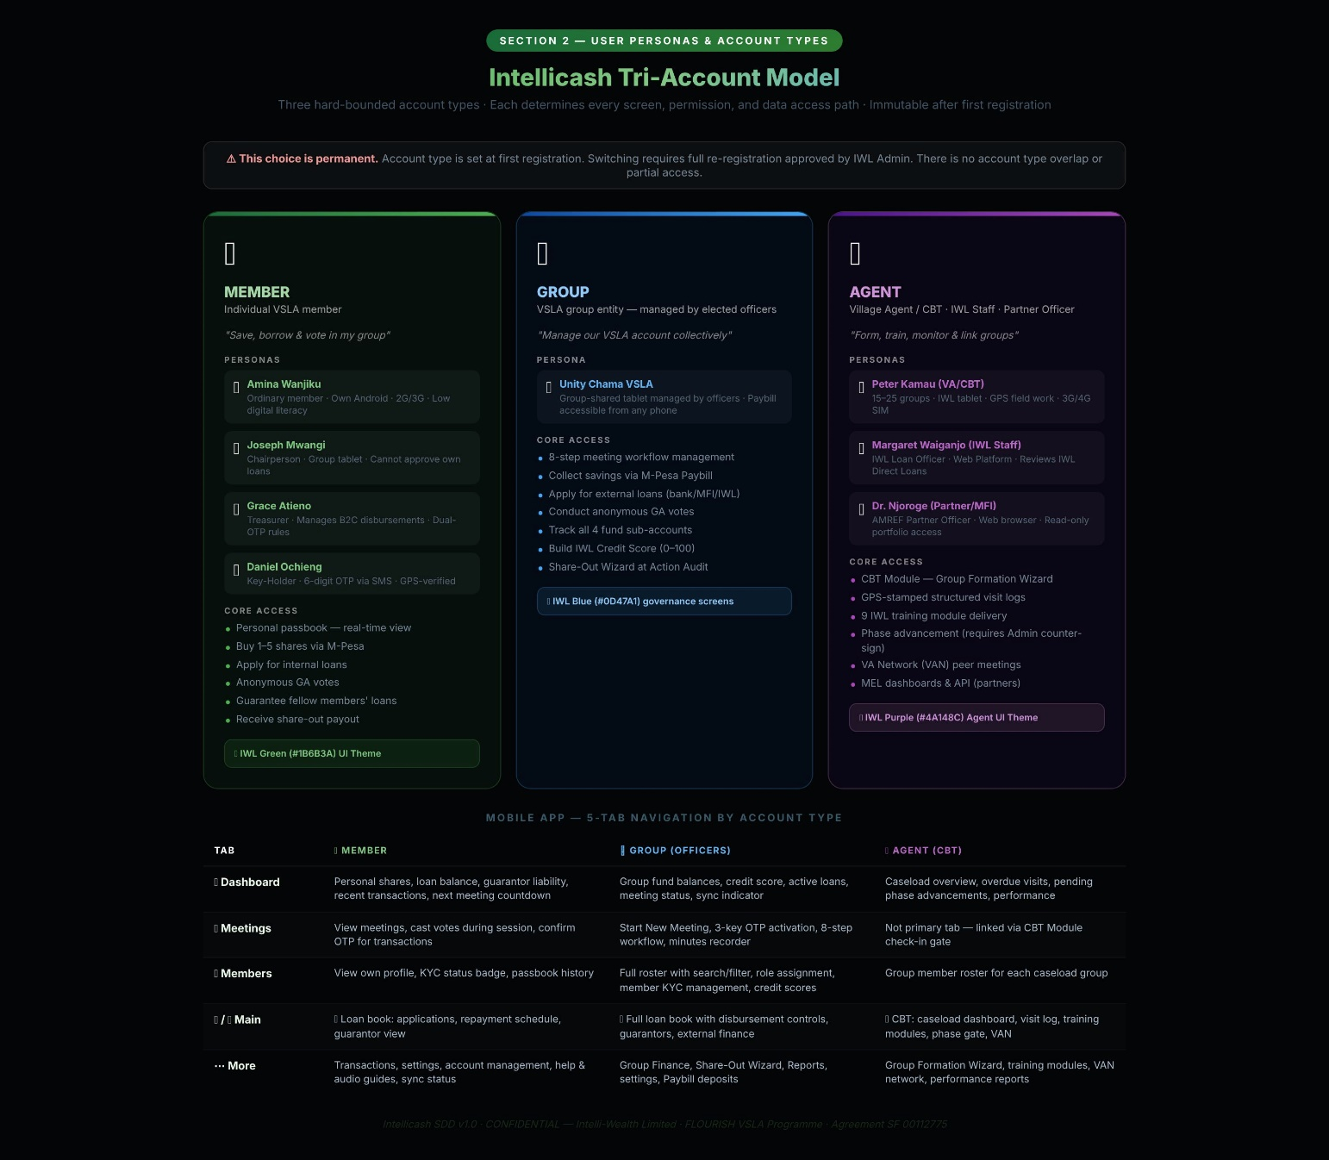

2.2 Member Account Personas
👤 Amina Wanjiku
Ordinary VSLA Member · Account Type: MEMBER
Device / Access | Own Android smartphone (low-to-mid range, 2G/3G)
Primary Goals | • View and track her personal digital passbook at any time  • Buy 1–5 shares per meeting using M-Pesa  • Apply for and receive internal loans  • Cast anonymous votes in General Assembly  • Guarantee a fellow member's loan  • Receive share-out payout at end of cycle
Key Challenges | • Low digital literacy — needs icon-first UI with Kiswahili labels  • Fear of digital fraud — prefers to see transactions confirmed publicly  • Intermittent mobile data and power access  • Does not trust systems she cannot explain to her neighbours

👤 Joseph Mwangi
Group Chairperson · Account Type: MEMBER (Officer)
Device / Access | Group-owned shared tablet (Android, managed by IWL)
Primary Goals | • Open and close meeting sessions (requires 3-key OTP to be verified)  • Table resolutions and oversee the 8-step meeting agenda  • Cannot approve his own loan application or vote on his own motion  • Oversee compliance with VSLA constitution  • Escalate disputes and anomalies to the VA or IWL Admin
Key Challenges | • Pressure from members to speed up or skip steps — platform must enforce order, not rely on him  • Risk of over-reach — system must enforce separation of duties  • Managing group dynamics with a digital tool that some members distrust

👤 Grace Atieno
Group Treasurer · Account Type: MEMBER (Officer)
Device / Access | Group-owned shared tablet
Primary Goals | • Confirm fund counts after each step — Loan Fund, Social Fund, External Fund  • Initiate and confirm M-Pesa B2C disbursements within active sessions  • Run the Share-Out Wizard at Action Audit  • Reconcile paybill deposits from IWL Custodian Account  • Cannot disburse to herself without dual officer OTP
Key Challenges | • M-Pesa delays mid-meeting create member anxiety  • Reconciling offline records with sync'd data after connectivity outage  • Dual-authority rules slow operations — platform must make dual sign-off fast, not bureaucratic

🗝 Daniel Ochieng
Key-Holder (1 of 3) · Account Type: MEMBER (Key-Holder)
Device / Access | Own phone — must be present at meetings
Primary Goals | • Receive 6-digit OTP via SMS at start of each meeting  • Read out OTP aloud to the group; Secretary enters it into the Group Account  • GPS must confirm Daniel is within 50m of meeting location  • Cannot simultaneously hold a Management Committee officer role
Key Challenges | • SMS delays in areas with weak Safaricom signal  • Phone battery — must arrive with charged phone  • Social pressure if he is late and blocking the meeting from starting

2.3 Group Account Personas
🏘 Unity Chama VSLA
VSLA Group Entity (managed by elected officers) · Account Type: GROUP
Device / Access | Group-shared tablet managed by officers; Paybill accessible from any phone
Primary Goals | • Manage group meetings through the 8-step workflow  • Collect savings via M-Pesa Paybill into IWL Custodian Account (no bank account)  • Apply for and manage external loans from banks, MFIs, and IWL Direct  • Conduct anonymous General Assembly votes  • Track all fund sub-accounts: Loan Fund, Social Fund, External Fund, Custodian  • Build IWL Credit Score to access formal financial services
Key Challenges | • Group has no bank account — relies on Paybill custodian model  • Managing multiple concurrent fund types without commingling  • Collective trust in the platform — if one member distrusts, others may follow

2.4 Agent Account Personas
🤝 Peter Kamau
Village Agent / Community-Based Trainer (CBT) · Account Type: AGENT
Device / Access | IWL-issued Android tablet; 3G/4G SIM
Primary Goals | • Form new VSLA groups through the digital Group Formation Wizard  • Log GPS-stamped structured visit notes for each group in caseload  • Deliver IWL's 9 training modules via the CBT Module  • Score group quality using 12 IWL indicators  • Advance groups through lifecycle phases (requires IWL Admin counter-sign)  • Manage VAN — Village Agent Network — peer meetings and cross-group learning
Key Challenges | • Large caseloads with 15–25 groups across remote areas  • Intermittent connectivity in field locations  • Balancing data quality with speed during village visits

🏢 Margaret Waiganjo
IWL Loan Officer · Account Type: AGENT (IWL Staff)
Device / Access | Web platform + Mobile (IWL office device)
Primary Goals | • Review IWL Direct Loan applications submitted by groups  • Access group credit score breakdown and passbook history  • Approve and initiate Paystack disbursements to qualifying groups  • Monitor repayment schedules and flag arrears  • Generate loan statements for partner and regulatory reporting
Key Challenges | • Verifying group eligibility across multiple data sources  • Paystack disbursement errors to unregistered phone numbers  • Coordinating with groups who cannot access digital repayment channels

🌐 Dr. Njoroge — AMREF
Partner Officer / Bank/MFI Representative · Account Type: AGENT (Partner)
Device / Access | Web browser (office or field laptop)
Primary Goals | • View credit-eligible group portfolio via Web Platform  • Access IWL Credit Score and credit data package per group  • Submit group loan approval or counter-offer  • Monitor external loan repayment schedules  • Export MEL indicators and programme impact data
Key Challenges | • Data reliability concerns — needs immutable audit trail to trust the data  • Regulatory requirements for collateral and KYC documentation  • Approval workflow delays within partner organisation

SECTION 3
Use Cases
Detailed interaction specifications for key system functions

Use cases describe the primary interactions between personas and the Intellicash system. Each use case is a binding specification for the developer — the system must implement every step exactly as described. Exception flows are not optional edge-case handling; they are required production behaviour.

UC-01: OTP-Activated Meeting — Three-Key Protocol
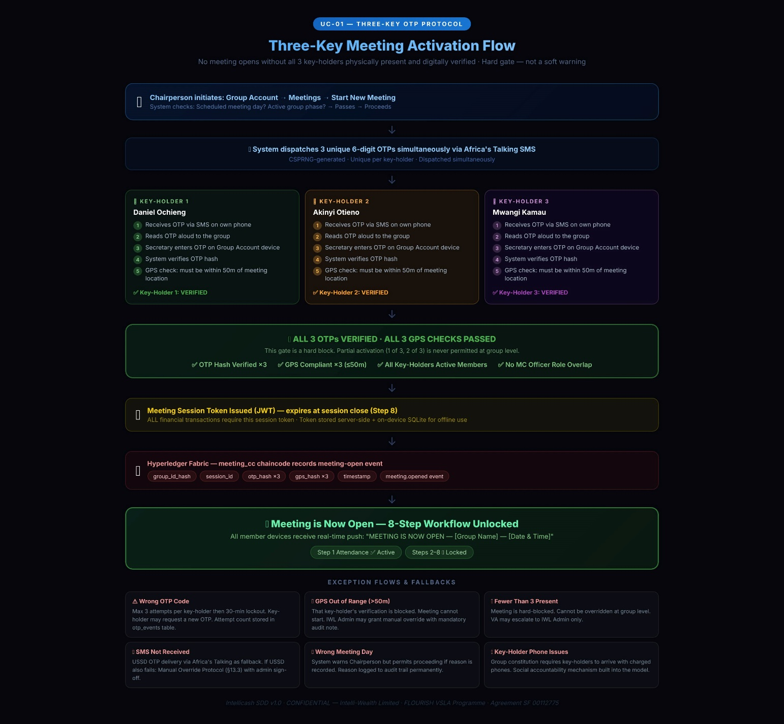
UC-01 | OTP-Activated Meeting — Three-Key Protocol
Primary Actor | Key-Holder ×3 (Daniel, two others) + Group Chairperson + Group Secretary
Trigger | Chairperson initiates a new meeting session in the Group Account → Meetings → Start New Meeting
Pre-conditions | Group is active; 3 Key-Holders are designated and enrolled with verified phone numbers; GPS meeting location is registered; all 3 Key-Holders are physically present; meeting date matches scheduled meeting day in group constitution.
Main Flow | 1. Chairperson opens Intellicash Group Account → Meetings → Start New Meeting.  2. System checks: Is today a scheduled meeting day? Is the group in an active phase? Passes — proceeds.  3. System generates three unique 6-digit OTPs via CSPRNG and dispatches via Africa's Talking SMS to each Key-Holder's registered number simultaneously.  4. Key-Holder 1 receives SMS. Reads OTP aloud to the group. Secretary enters it into the 'Key-Holder 1 OTP' field on the Group Account shared device.  5. System verifies OTP hash, checks GPS of Key-Holder 1's device (must be within 50m of registered meeting GPS). Marks Key-Holder 1: VERIFIED ✅.  6. Key-Holder 2 repeats the same process. System marks Key-Holder 2: VERIFIED ✅.  7. Key-Holder 3 repeats the same process. System marks Key-Holder 3: VERIFIED ✅.  8. All 3 OTPs verified and all 3 GPS checks passed. System issues a Meeting Session Token (JWT, expires at session close).  9. Blockchain (Hyperledger Fabric — meeting_cc chaincode) records: meeting-open event with group_id, session_id, OTP hash for each key-holder, GPS hash, timestamp.  10. All member devices connected to the group receive a real-time push: 'MEETING IS NOW OPEN — [Group Name] — [Date & Time].'  11. Meeting Step 1 (Opening & Attendance) is now active. 8-step workflow engine is unlocked.
Post-conditions | Meeting session is active with a valid session token; all financial transactions are permitted; blockchain records the open event; all member passbooks are live.
Exceptions / Alt Flows | • OTP fails (wrong code): system allows max 3 attempts per key-holder then 30-min lockout. Key-Holder may request a new OTP.  • GPS out of range (>50m): system blocks that key-holder's verification; notifies Chairperson. Meeting cannot start until all 3 GPS checks pass. IWL Admin can grant a manual override with a mandatory audit note.  • Fewer than 3 Key-Holders physically present: meeting is blocked. System cannot be overridden at group level. VA may escalate to IWL Admin.  • OTP SMS not received (no signal): Key-Holder requests USSD OTP delivery as fallback. If USSD also fails: Manual Override Protocol (see §13.3).  • Wrong meeting day: system warns Chairperson but permits proceeding if Chairperson records reason (logged to audit trail).

UC-02: Member Internal Loan Application with Credit Guarantee
UC-02 | Member Internal Loan Application with Credit Guarantee
Primary Actor | VSLA Member (borrower) + Guarantor Members (1–3) + General Assembly + Treasurer
Trigger | Meeting is active (session token valid); Step 6 — Loan Applications — is current step
Pre-conditions | Meeting session is open; borrower is an active member; Loan Fund has sufficient balance; step 6 is current step in workflow.
Main Flow | 1. Member states loan purpose aloud to group. Secretary captures it in the app: Group Account → Meeting → Step 6 → New Loan Application.  2. System performs automatic eligibility check: borrower's share_value × 3 = maximum loan amount. Checks displayed to group.  3. Secretary records requested amount and purpose. System auto-calculates service charge (flat % × months) and repayment schedule.  4. Member nominates 1–3 fellow active members as Credit Guarantors. System sends in-app notification to each nominated guarantor's Member Account.  5. Each nominated guarantor must Accept or Decline within the active meeting session. Liability amount is displayed clearly: 'If [borrower] defaults, you are liable for KES [amount].'  6. At least 1 guarantor accepts. All acceptances are recorded; blockchain writes guarantee.accepted event for each guarantor.  7. Chairperson tables the loan for GA vote. Anonymous ballot is opened: members tap Yes / No / Abstain on their Member Account devices.  8. Vote closes after all present members have voted or 3-minute timer expires. Quorum check: 75% Yes required.  9. Vote result is blockchain-hashed (SHA-256 of resolution_id + yes + no + abstain + timestamp). Resolution sealed.  10. If 75% Yes: system unlocks M-Pesa B2C disbursement. Treasurer initiates. Borrower's Member Account displays OTP request.  11. Borrower confirms receipt via OTP. M-Pesa B2C payment confirmed. Passbook updated live with loan entry and repayment schedule.  12. Blockchain records: loan_disbursed event with loan_id, borrower_id, amount, guarantors[], vote_hash, mpesa_ref, timestamp.
Post-conditions | Loan disbursed; passbook updated; repayment schedule active; guarantor passbooks flagged 'Guarantor Liability: KES [amount]'; blockchain record immutable; lender API updated.
Exceptions / Alt Flows | • No guarantor accepts within session: loan application is suspended. Member may resubmit at next meeting with new guarantors.  • Vote fails quorum: loan rejected; Chairperson records reason; member may reapply next meeting. Blockchain records failed vote.  • Loan Fund insufficient: system blocks disbursement. Chairperson may reduce loan amount or defer.  • M-Pesa B2C fails: payment queued; Treasurer retries or initiates fallback. Loan status = 'Disbursement Pending' until confirmed.  • Guarantor later requests to withdraw: only permitted before disbursement. After disbursement, guarantee cannot be withdrawn.  • Borrower defaults: Guarantee Service calls guarantee on defaulting loan. Guarantor notified via SMS and in-app. Guarantor's share balance is flagged.

UC-03: Group Saves via IWL Paybill (No Bank Account)
UC-03 | Group Saves via IWL Paybill (No Bank Account)
Primary Actor | Group Member or Treasurer (any phone) → IWL Paybill Service → Group Treasurer (allocation)
Trigger | Group needs to deposit savings, repay an external loan, or transfer funds; group has no bank account
Pre-conditions | Group Account is active; IWL Paybill number (522522) is configured; group has a unique Account Reference (GRP-XXXXX); Treasurer is enrolled.
Main Flow | 1. Member or Treasurer dials M-Pesa on any phone. Goes to: M-Pesa → Lipa Na M-Pesa → Pay Bill.  2. Enters IWL Paybill Business Number: 522522.  3. Enters group's unique IWL Account Reference as the Account Number (e.g., GRP-00445).  4. Enters amount and M-Pesa PIN. Confirms payment. M-Pesa sends confirmation SMS to sender.  5. M-Pesa Daraja v3 fires a C2B webhook to IWL API Gateway with: TransactionID, amount, AccountReference, sender phone, timestamp.  6. Paybill Service receives webhook; validates signature; matches AccountReference to group_id in group_accounts table.  7. Paybill Service creates a paybill_transactions record. Credits group's custodian_balance_kes in group_accounts.  8. Blockchain (payment_cc) records: paybill.received event with paybill_txn_id, group_id hash, amount, mpesa_txn_id, timestamp.  9. Notification Service sends SMS to Treasurer's registered phone and in-app push to Group Account: 'KES [amount] received. Reference: [GRP-XXXXX]. Please allocate to a fund.'  10. Treasurer opens Group Account → Finance → Paybill Deposits → Allocate. Selects fund: Loan Fund / Social Fund / External Loan Repayment.  11. Fund Service credits selected fund namespace. Paybill transaction record updated: allocation_fund set, allocated_at timestamp.  12. Group Account dashboard reflects updated fund balances immediately.
Post-conditions | Funds are credited to IWL Custodian sub-account; Treasurer has allocated to correct fund; group ledger is updated; blockchain record is immutable; partner Web Platform reflects updated balances.
Exceptions / Alt Flows | • Wrong account reference entered: funds land in 'unmatched_holding' queue. IWL Finance reviews within 24 hours and manually matches or refunds via M-Pesa reversal.  • M-Pesa reversal received: Paybill Service handles reversal webhook; debits custodian balance; notifies Treasurer. If already allocated: Fund Service reverses allocation.  • Treasurer does not allocate within 48h: system sends reminder. After 72h: IWL Admin is alerted.  • Group later opens a bank account: IWL Finance processes an EFT of custodian balance to bank account on group request. Custodian sub-account is closed after confirmation.

UC-04: Group Applies for External Loan (Bank or MFI)
UC-04 | Group Applies for External Loan (Bank or MFI)
Primary Actor | Group Chairperson + General Assembly + External Lender (via API or Web Platform)
Trigger | Group wants formal credit; Chairperson initiates application in Group Account → Group Finance → External Loans
Pre-conditions | Group Credit Score ≥ 75; meeting is OTP-activated; group has no other active external loan of the same type; GA has not rejected this application this cycle.
Main Flow | 1. Chairperson opens Group Account → Group Finance → External Loans → Apply for External Loan.  2. System displays eligible lenders filtered by group credit score and lifecycle phase. Shows loan products, rates, and terms for each.  3. Chairperson selects lender and loan product. Enters requested amount and purpose.  4. System compiles IWL Credit Data Package: credit score, passbook summary, meeting attendance history, repayment record, constitution compliance score.  5. Chairperson tables as GA Resolution. System opens anonymous ballot. 75% Yes required.  6. Vote result is blockchain-hashed. On passing: system submits credit data package to lender API (or lender receives notification to review via Web Platform).  7. Lender reviews on Web Platform. Issues approval, counter-offer, or rejection.  8. On approval: disbursement is routed to group's External Loan Sub-Account (if bank account exists) or IWL Custodian Account (if Paybill-only group).  9. Group Account notified: 'External loan of KES [amount] approved by [Lender]. Disbursement confirmed.'  10. External Loan Sub-Account is credited. Repayment schedule loaded into Group Account → Group Finance → External Loans → Active Loans.  11. Blockchain records: extloan.disbursed event with application_id, lender_id, group_id hash, amount, vote_hash, disbursement route, timestamp.
Post-conditions | External loan credited to segregated sub-account; repayment schedule active; group ledger reflects new liability; lender API shows active loan; partner Web Platform dashboard updated.
Exceptions / Alt Flows | • Credit score below 75: system blocks application and shows factor breakdown, advising group on how to improve each factor.  • Lender declines: group notified with reason. Reapplication permitted after 30 days.  • Group already has active external loan of same type: system prevents second application until first is repaid or restructured.  • Disbursement to IWL Custodian (no bank account): group must sign IWL Custodian Agreement before disbursement routes to Paybill.  • Group defaults: Early Warning System triggers when repayment rate drops below 70%. IWL Admin and VA are alerted. Loan restructuring workflow is activated.

UC-05: IWL Direct Loan Application via Paystack
UC-05 | IWL Direct Loan Application via Paystack
Primary Actor | Group Treasurer + General Assembly + IWL Loan Officer (Web Platform)
Trigger | Group applies for a direct loan from Intelli-Wealth Limited; Group Account → Group Finance → IWL Direct Loans
Pre-conditions | Group Credit Score ≥ 80; group has completed at least 1 full operating cycle; no active IWL Direct Loan outstanding; GA vote has not been conducted this cycle for IWL loan.
Main Flow | 1. Treasurer opens Group Account → Group Finance → IWL Direct Loans → Apply.  2. System checks eligibility: credit score, cycle count, outstanding IWL loan balance. If eligible: application form is displayed.  3. Treasurer enters: requested amount, loan purpose, preferred repayment period (3–12 months).  4. System auto-computes: maximum eligible amount (based on savings pool × IWL lending formula), service charge schedule, and repayment schedule.  5. Application is tabled as GA Resolution. Anonymous ballot: 75% Yes required. Blockchain-hashed.  6. On passing: application is submitted to IWL Loan Officer queue on Web Platform. Status = 'Under Review'.  7. IWL Loan Officer reviews on Web Platform: credit score breakdown, passbook PDF, meeting history, existing liabilities.  8. IWL Loan Officer approves (or adjusts amount) and initiates Paystack transfer from IWL Lending Fund sub-account.  9. Paystack transfer confirmed. Group Account notified: 'IWL Direct Loan of KES [amount] disbursed via Paystack. Repayment begins [date].'  10. Repayment schedule is loaded into Group Account. Members can repay via: (a) Paybill using loan reference, or (b) Paystack payment link.  11. Blockchain records: iwl_loan.disbursed event with iwl_loan_id, paystack_txn_ref, group_id hash, amount, officer_id, repayment_schedule_hash.
Post-conditions | Loan disbursed; repayment schedule active; IWL Finance Web Platform shows live loan status; blockchain record immutable; credit score monitoring begins for this loan.
Exceptions / Alt Flows | • Paystack transfer fails: IWL Loan Officer retries or switches to M-Pesa B2C fallback. Loan status remains 'Disbursement Pending'.  • IWL Loan Officer rejects application: group notified with written reason. Reapplication after 60 days.  • Group misses repayment: system auto-alerts IWL Loan Officer at Day 7 overdue. Credit score is penalised from Day 1 overdue.  • Credit score drops below 80 after disbursement: monitoring only — loan already disbursed. Flagged for enhanced monitoring.  • Paystack account details change: group must update via Group Account → Settings → Payment Details. IWL Admin confirms before next disbursement.

UC-06: Village Agent Forms a New VSLA Group
UC-06 | Village Agent Forms a New VSLA Group
Primary Actor | Village Agent / CBT (Agent Account)
Trigger | Agent has been assigned a community; opens Agent Account → CBT Module → New Group Formation
Pre-conditions | Agent Account is active and verified; community assessment has been completed offline; IWL Programme Admin has authorised caseload assignment for this community.
Main Flow | 1. Agent opens Agent Account → CBT Module → Form New Group.  2. Agent enters: group name, GPS coordinates of regular meeting location (device GPS auto-fills), community name, county, sub-county.  3. Agent registers founding members one by one: National ID, phone number, photo. System runs IPRS KYC verification for each member automatically.  4. Agent designates 5 Management Committee officers from the verified member list: Chairperson, Secretary, Treasurer, Money Counter 1, Money Counter 2.  5. Agent designates 3 Key-Holders. System enforces: Key-Holders CANNOT be MC officers. If overlap attempted: hard block with explanation.  6. Agent configures group constitution via the Constitution Wizard: share denomination (KES), max shares per meeting, Social Fund rate (flat per meeting), loan service charge (% per month), fine schedule for absence/tardiness.  7. Agent sets meeting schedule: day of week, time, frequency (weekly in Intensive phase).  8. Agent confirms GPS meeting location on map. Group is created. System auto-generates: group_id, unique Paybill Account Reference (GRP-XXXXX), IWL Credit Score starting baseline.  9. Group Account is provisioned and linked to all registered members' Member Accounts.  10. Agent submits group to IWL Programme Admin for counter-sign. Admin reviews and activates group on Web Platform.  11. Blockchain records: group.created event with group_id, agent_id, constitution_hash, GPS hash, timestamp.
Post-conditions | VSLA group is active; all members have linked Member Accounts; Group Account is ready; Paybill reference is live; group appears on VA caseload dashboard and partner Web Platform portfolio.
Exceptions / Alt Flows | • IPRS KYC fails for a member: member registered as 'Pending Verification' — limited access until manual KYC completed within 48 hours.  • Duplicate phone number detected: system flags potential duplicate member. Agent must resolve (different person sharing a phone is documented with a note).  • GPS location unavailable (deep rural): Agent enters coordinates manually from offline map. IWL Admin verifies via satellite imagery on Web Platform before activating.  • IWL Admin rejects group: reason provided. Agent must address issues and resubmit.

UC-07: Share-Out — End-of-Cycle Action Audit
UC-07 | Share-Out — End-of-Cycle Action Audit
Primary Actor | Treasurer + Chairperson + all members (Group Account + Member Accounts)
Trigger | Group has completed 12-month operating cycle; VA has signed off on Action Audit; Chairperson opens Share-Out Wizard
Pre-conditions | Cycle is complete (12 months); VA has submitted Action Audit sign-off on CBT Module; IWL Admin has confirmed Action Audit on Web Platform; all outstanding loans are resolved or written off; all external loans are repaid.
Main Flow | 1. Treasurer opens Group Account → Share-Out Wizard → Begin Action Audit.  2. System runs pre-share-out audit: checks all loans are resolved; checks all external liabilities are cleared; checks any active guarantees are discharged.  3. System computes each member's share-out entitlement: shares held × current share value + proportional interest earned − any outstanding fines or loan liabilities.  4. Share-out schedule is displayed to all member devices in real time: each member can see their own entitlement.  5. Chairperson tables the share-out schedule as a GA Resolution for approval.  6. GA votes: simple majority required to approve the schedule.  7. On approval: Treasurer initiates M-Pesa B2C batch payout. Each member's phone receives payment.  8. Each member confirms receipt via OTP in their Member Account.  9. Passbook entry for each member: CYCLE CLOSED — Share-Out Received: KES [amount] — [date].  10. Blockchain records: shareout.disbursed event for each member with shareout_id, member_id, amount, mpesa_ref, otp_confirmed.  11. Group cycle counter increments. Constitution is reset to current version. New cycle begins.
Post-conditions | All members have received their share-out; all passbooks are marked CYCLE CLOSED for the completed cycle; blockchain records are immutable; partner Web Platform shows cycle completion; new cycle is active.
Exceptions / Alt Flows | • Member's M-Pesa B2C fails (unregistered number, limit reached): funds held in Pending Payout status. Treasurer manually re-initiates within 48 hours or arranges cash payment with dual officer sign-off.  • Member has outstanding loan at share-out: loan balance is deducted from share-out entitlement. If loan exceeds entitlement: deficit is written off with GA vote and documented in audit log.  • Active guarantor liability at share-out: guarantor's entitlement is held in escrow until borrower's loan is resolved.  • Member disputes share-out amount: Chairperson opens dispute in Group Account. IWL Admin reviews passbook audit trail. Resolution within 7 days.

SECTION 4
System Architecture
Platform structure, layers, and technology stack

4.1 Architecture Overview
Intellicash is built on a microservices architecture with a clear separation between the mobile presentation layer (Members, Officers, Agents), the web presentation layer (Partners, Banks, IWL Admin), and the backend service layer. All services communicate through a central API Gateway. The data layer uses PostgreSQL for transactional data and Hyperledger Fabric for immutable blockchain records.

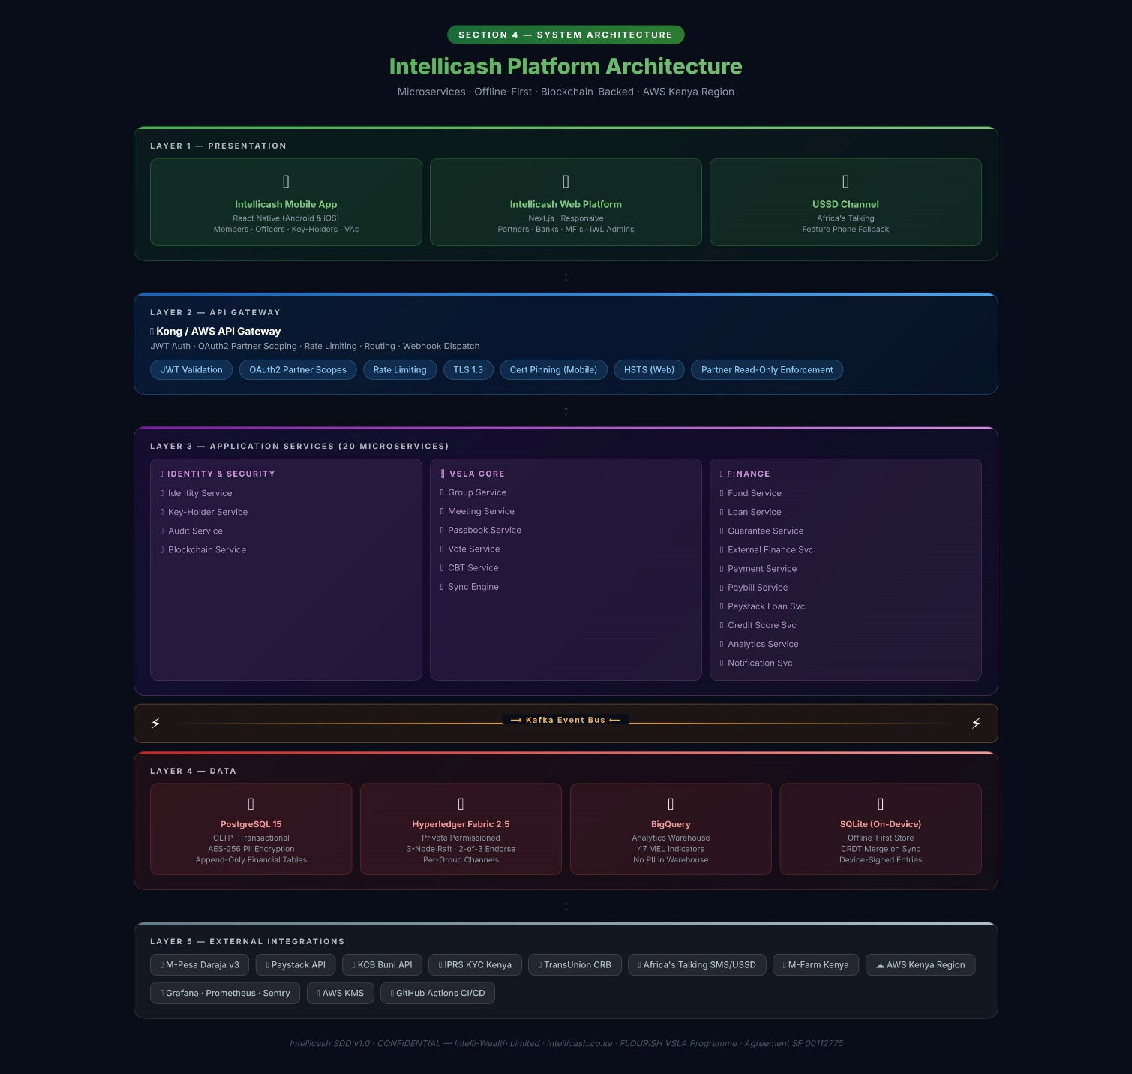

4.2 Architecture Layers
Layer | Components | Technology | Key Requirements
Presentation — Mobile | Intellicash Mobile App (Android/iOS) USSD fallback for feature phones | React Native (single codebase) Africa's Talking USSD | Offline-first; role-based UI; icon-first; Kiswahili primary; audio prompts
Presentation — Web | Intellicash Web Platform API Developer Portal | Next.js / React.js Responsive (desktop & mobile) | Read-only for partners; real-time dashboard; MEL export; API portal
API Gateway | Auth, routing, rate limiting, webhook dispatch, partner scope enforcement | Kong Gateway / AWS API Gateway | JWT validation; OAuth2 for partner APIs; per-partner data scoping
Application Services | 20 domain microservices (see §6) | Node.js / TypeScript Python/Django (ML & analytics) | Each service owns its DB namespace; no direct cross-service DB access
Event Streaming | Async inter-service communication; payment event processing | Apache Kafka | At-least-once delivery; consumer groups per service; DLQ for failed events
Blockchain | Immutable transaction ledger for all financial events | Hyperledger Fabric 2.5 Golang chaincode | Private permissioned; 3-node Raft; 2-of-3 endorsement; per-group channels
Data — Transactional | All structured operational data | PostgreSQL 15 (Read replica for analytics feeds) | Append-only financial tables; AES-256 at rest; field-level encryption for PII
Data — Analytics | KPI computation, MEL indicators, partner dashboards | BigQuery TensorFlow Lite (credit scoring) | Separate from OLTP; batch-updated via Kafka consumer; no PII in warehouse
Offline Sync | Local data store on Mobile App; conflict-free merge on reconnect | SQLite (on-device) CRDT merge algorithm IWL Sync Engine | Full 8-step meeting works offline; OTP pre-cached; M-Pesa queue on reconnect
Infrastructure | Cloud hosting, CI/CD, secrets, monitoring, alerting | AWS Kenya Region GitHub Actions AWS KMS Grafana / Prometheus / Sentry | Kenya-resident data; 99.5% uptime SLA; automated rollback on failed deploy

4.3 Two-Product Architecture
Product | Primary Users | Channel | Core Purpose
Intellicash Mobile App | VSLA Members, Group Officers, Key-Holders, Village Agents / CBTs | Android & iOS Native App (React Native) | End-to-end VSLA lifecycle management: meetings, passbooks, loans, voting, CBT field work, group formation
Intellicash Web Platform | Partner Officers (NGO, MFI, Govt), Banks & Lenders, IWL Programme Administrators, IWL Loan Officers | Responsive web browser (Next.js) | Portfolio intelligence, MEL reporting, partner administration, IWL loan management, system configuration, API developer portal

SECTION 5
Mobile App — Module Specifications
Screen-by-screen functional requirements for the Intellicash Mobile App

5.1 Navigation Structure
The Mobile App uses a five-tab bottom navigation bar. Tabs and visible actions adapt dynamically to the logged-in user's account type and role. No tab or action belonging to another role may ever be visible, even partially, to a user who does not hold that role.

Tab | Visible To | Key Screens & Actions
🏠 Dashboard | All roles | Role-specific overview; Quick Actions (context-sensitive); Recent Transactions list; Group KPI summary; Sync status indicator; Next meeting countdown
📅 Meetings | Officers, Members | Meeting list with status; Start New Meeting (officers); 3-tab session view (Attendance | Shares | Actions); 8-step enforced workflow; Minutes recorder; OTP activation panel
👥 Members | Officers, Members | Member roster with search/filter; Individual passbook view; Member profiles; KYC status badge; Role assignment (officers only); Credit score view (officers only)
💰 Loans / 🎓 CBT | Officers/Members: Loan book Agents: CBT Module | Officers/Members: Loan applications, repayment schedule, disbursement status, guarantor view Agents: Caseload dashboard, visit log, training modules, phase advancement, VAN
⋯ More | All roles (context-specific) | Group Finance (officers); Share-Out Wizard (Treasurer); Reports (officers); Transactions; Settings & Security; Sync status; Account Management; Help & Audio Guides

5.2 IWL 8-Step Meeting Workflow
The Workflow Engine enforces strict procedural order. The Chairperson CANNOT skip, reorder, or reverse any step. The system must make it technically impossible to access Step N+1 before Step N is formally closed. This is not a UX preference — it is a core integrity requirement.
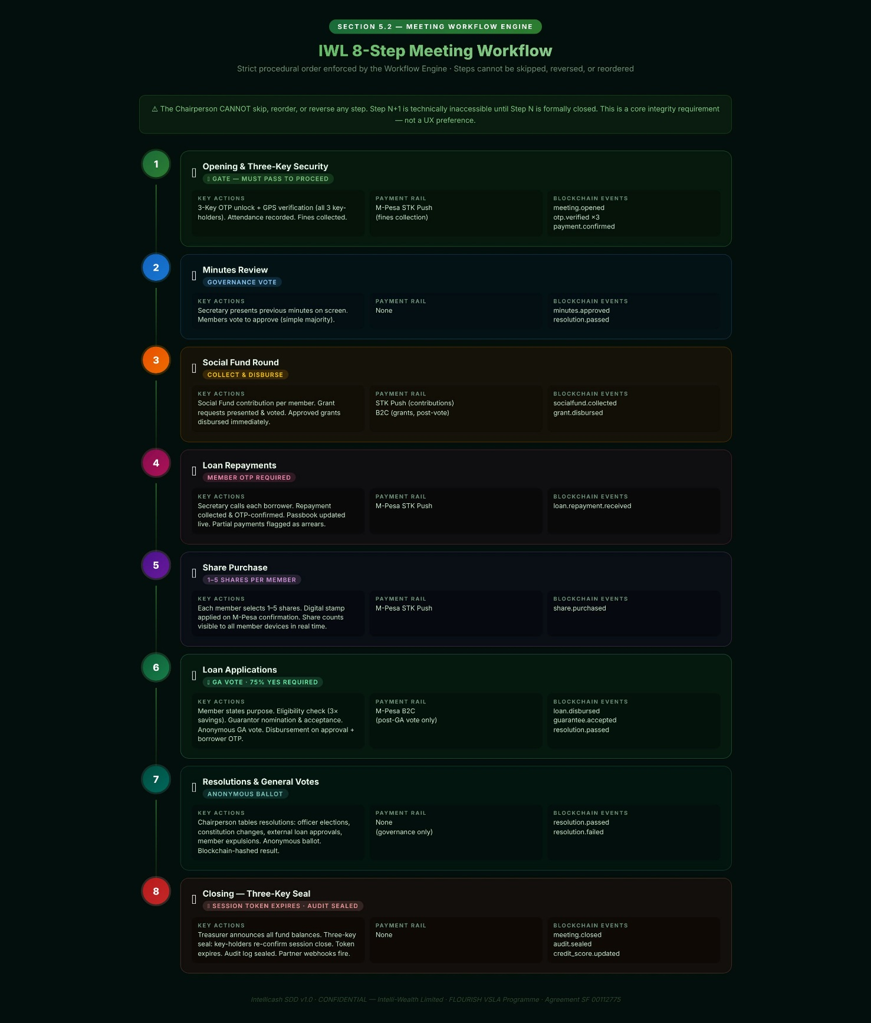
Step | Name | Key Actions Required | Payment Rail | Blockchain Event
1 | Opening & Three-Key Security | Three-key OTP unlock + GPS verification for all 3 key-holders. Attendance recorded for all members (present/absent/late). Fines collected from absent and late members. | M-Pesa STK Push (fines) | meeting.opened; otp.verified ×3
2 | Minutes Review | Secretary presents previous meeting minutes on screen. Members vote to approve via quick ballot (simple majority). Status set to Approved. | None | minutes.approved
3 | Social Fund Round | Secretary calls each member by name. Social Fund contribution collected from each. Grant requests presented and voted on. Approved grants disbursed immediately. | STK Push (contributions); B2C (grants post-vote) | socialfund.collected; grant.disbursed
4 | Loan Repayments | Secretary calls each borrower by name. Repayment collected. Borrower OTP-confirms. Passbook entry updated live. Any partial payments flagged as arrears. | M-Pesa STK Push | loan.repayment.received
5 | Share Purchase | Secretary calls each member. Member selects 1–5 shares. Digital stamp applied on M-Pesa payment confirmation. Share count visible to all member devices in real time. | M-Pesa STK Push | share.purchased
6 | Loan Applications | Member states purpose. Eligibility check (3× savings). Guarantor nomination and acceptance. GA anonymous vote. Disbursement on approval with borrower OTP. | M-Pesa B2C (on GA approval) | loan.disbursed; guarantee.accepted
7 | Resolutions & General Votes | Chairperson tables other resolutions (officer elections, constitution changes, external loan approvals, member expulsions). Anonymous ballot. Blockchain-hashed result. | None (governance only) | resolution.passed / .failed
8 | Closing | Treasurer announces all fund balances. Three-key seal: key-holders re-confirm session close. Session token expires. Audit log sealed. Webhooks fire to partner Web Platform. | None | meeting.closed; audit.sealed

5.3 CBT / Village Agent Module
Feature | Description | Data Captured | Blockchain?
Caseload Dashboard | All assigned groups with phase, last visit date, quality score, and next required visit date. Colour-coded by risk level. | group_id, phase, last_visit_date, quality_score | No
Group Formation Wizard | Step-by-step guided group formation: member registration, IPRS KYC, officer assignment, key-holder designation, constitution configuration, GPS setup. | All group_accounts and group_members fields | Yes — group.created
Structured Visit Log | GPS-stamped visit record using IWL's 12-indicator quality checklist. Photo upload. VA observations. Group response notes. | visit_id, group_id, agent_id, GPS, timestamp, 12 indicator scores, photos | No — but GPS-stamped
Training Module Delivery | 9 IWL training modules delivered via app. Group members follow on own Member Account devices. Completion tracked per member per module. | training_completion per member_id | No
Quality Score Auto-Computation | Score auto-computed from: attendance (20%), passbook accuracy (20%), repayment rate (25%), constitution compliance (20%), visit compliance (15%). | quality_score updated post each visit | No
Phase Advancement | VA signs off on phase advancement in CBT Module. IWL Programme Admin counter-signs on Web Platform. Partner notified via webhook. Group constitution may update with new requirements. | phase_advancement_id, agent_sign_off, admin_sign_off | No
VA Network (VAN) | Peer VA network: register, schedule VAN meetings, share cross-group learning notes, access VA credit fund information. | van_meeting records, learning_notes | No

5.4 Share-Out Wizard
Wizard Step | Action | System Check | Output
1. Pre-Audit Checks | System auto-checks all outstanding loans, liabilities, and guarantees | All loans resolved? All external repaid? All guarantees discharged? | Pass/Fail report shown to Treasurer
2. Interest Calculation | System computes total interest earned on loan fund across full cycle | Interest income = sum of all service charges collected | Interest total displayed to group
3. Share-Out Computation | System computes each member's entitlement: shares × value + pro-rata interest − liabilities | Validated against total fund balance (must balance to zero) | Per-member entitlement schedule
4. GA Vote on Schedule | Chairperson tables schedule as Resolution; GA votes | Simple majority required | Vote hash recorded on blockchain
5. M-Pesa B2C Batch | Treasurer initiates batch B2C payout to all members | Each transaction queued and dispatched sequentially | M-Pesa refs for each payment
6. Receipt Confirmation | Each member OTP-confirms receipt on Member Account | All members confirmed? Any pending? | Passbook: CYCLE CLOSED
7. Cycle Close | System closes cycle, increments counter, archives passbooks, opens new cycle | All confirmations received | New cycle active; old cycle archived

SECTION 6
Business Service Layer
All 20 microservices: responsibilities, rules, integrations, and events

6.1 Service Architecture Diagram
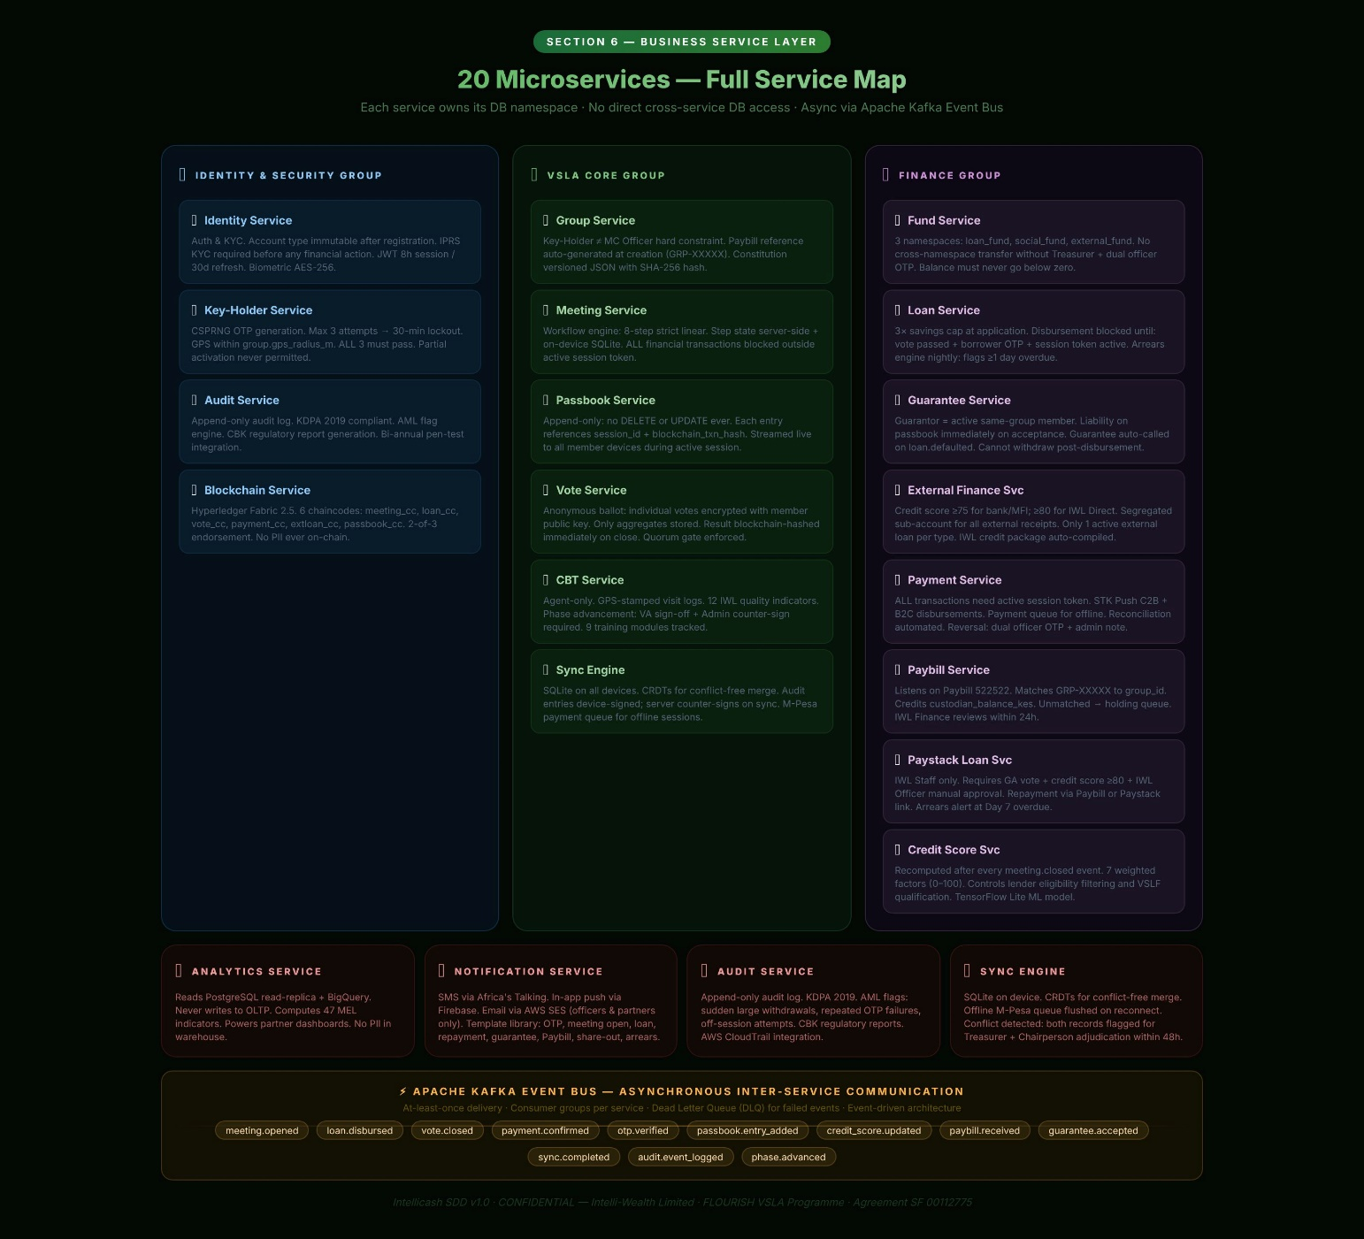

6.2 Service Specifications
Service | Domain | Key Business Rules (Non-Negotiable) | Integrations | Kafka Events Published
Identity Service | Auth & KYC | Account type is immutable after first registration (member/agent/iwl_staff/partner). IPRS KYC required before any financial action. Biometric hash stored AES-256 encrypted. JWT expiry: 8h session, 30 days refresh. | IPRS Kenya API Africa's Talking OTP Firebase Auth | user.registered user.kyc_verified user.login user.suspended
Group Service | VSLA Management | Key-Holders CANNOT be MC officers — hard system constraint. Paybill reference auto-generated at group creation (GRP-XXXXX). GPS radius default 50m; configurable by IWL Admin only. Constitution encoded as versioned JSON with SHA-256 hash. | IPRS Kenya GPS/Maps API | group.created group.phase_advanced group.constitution_amended group.activated
Meeting Service | Workflow Engine | 8-step linear workflow: cannot skip, reverse, or access Step N+1 before Step N closes. ALL financial transactions blocked outside an active session token. Step state stored server-side and on-device SQLite for offline use. | Key-Holder Service (OTP gate) Passbook Service Blockchain Service | meeting.opened meeting.step_completed meeting.closed meeting.abandoned
Key-Holder Service | Security | OTP generated as CSPRNG 6-digit code. Max 3 attempts per key-holder then 30-min lockout. GPS must be within group.gps_radius_m of meeting location. ALL 3 must pass before session token is issued. No partial activation permitted. | Africa's Talking SMS USSD (fallback OTP) GPS API | otp.sent otp.verified otp.failed otp.expired session.activated
Passbook Service | Ledger | Append-only: no DELETE or UPDATE permitted on any passbook_entries row. Ever. Each entry has: session_id reference (must match active session), blockchain_txn_hash. Passbook streamed live to all member devices during active session. | Blockchain Service Meeting Service | passbook.entry_added passbook.cycle_closed
Fund Service | Treasury | Three fund namespaces: loan_fund, social_fund, external_fund. No cross-namespace transfer without explicit Treasurer action + dual officer OTP. Custodian balance sub-ledger for Paybill-only groups tracked separately. Balance must never go below zero. | Paybill Service Payment Service Blockchain Service | fund.credited fund.debited fund.balance_updated fund.reconciled
Loan Service | Internal Credit | 3× savings cap enforced at application (not disbursement). Disbursement blocked until: vote_resolution.result='passed' AND borrower OTP confirmed AND session token active. Arrears engine runs nightly: flags loans overdue by ≥1 day. | Vote Service Payment Service Guarantee Service Blockchain Service | loan.applied loan.approved loan.disbursed loan.repaid loan.arrears_flagged loan.defaulted loan.written_off
Guarantee Service | Credit Guarantee | Guarantor must be active member of same group. Guarantee liability recorded on guarantor passbook immediately on acceptance. On loan.defaulted event: guarantee is automatically called. Guarantor notified via SMS and in-app. Guarantee cannot be withdrawn after disbursement. | Loan Service Passbook Service Notification Service Blockchain Service | guarantee.requested guarantee.accepted guarantee.declined guarantee.active guarantee.called guarantee.discharged
External Finance Service | External Credit & Grants | Credit score ≥75 required for bank/MFI applications; ≥80 for IWL Direct Loans. Segregated sub-account enforced for all external loan receipts. Only 1 active external loan per type at a time. IWL credit data package auto-compiled for lender API. Grant fund is completely ring-fenced. | Credit Score Service Payment Service Paystack Loan Service KCB Buni API Blockchain Service | extloan.applied extloan.approved extloan.disbursed extloan.repayment_received extloan.defaulted extloan.repaid grant.received grant.disbursed
Payment Service | Payments | ALL transactions must have active session token. M-Pesa STK Push for C2B (member-to-group). B2C for disbursements (group-to-member). Payment queue for offline sessions — executed in sequence on reconnect. Reconciliation automated. Reversal requires dual officer OTP + admin audit note. | M-Pesa Daraja v3 Paystack KCB Buni API Kafka (async events) | payment.initiated payment.confirmed payment.failed payment.queued payment.reversed payment.reconciled
Paybill Service | IWL Custodian Savings | Listens on M-Pesa webhook for Business No. 522522. Matches account reference (GRP-XXXXX) to group_id. Credits custodian_balance_kes. Unmatched refs → holding queue. IWL Finance reviews within 24h. Reversal handling via Daraja webhook. | M-Pesa Daraja v3 (Paybill C2B webhook) Fund Service Notification Service Blockchain Service | paybill.received paybill.matched paybill.unmatched paybill.allocated paybill.reversed
Paystack Loan Service | IWL Direct Lending | Only IWL Loan Officers (iwl_staff account type) can initiate disbursements. Group must have passed GA vote. Paystack sub-account per group for fund segregation. Repayment via Paybill or Paystack link. Arrears alert at Day 7 overdue. | Paystack API External Finance Service Notification Service Blockchain Service | iwl_loan.applied iwl_loan.approved iwl_loan.rejected iwl_loan.disbursed iwl_loan.repayment_received iwl_loan.arrears_flagged
Vote Service | Governance | Anonymous ballot: individual votes encrypted with member public key. Only aggregate stored in plain text. No officer, admin, or developer can view individual votes. Ever. Result blockchain-hashed immediately on close. Quorum gate: vote cannot close if minimum voters not reached. | Blockchain Service Notification Service | vote.opened vote.cast vote.closed resolution.passed resolution.failed resolution.quorum_invalid
Credit Score Service | Credit Intelligence | Score recomputed after every meeting.closed event. Factors: repayment 25%, savings 20%, attendance 15%, compliance 15%, social fund 10%, cycle age 10%, security 5%. Score used for lender eligibility filtering and VSLF qualification. | Meeting Service Loan Service Fund Service Analytics Service | credit_score.updated credit_score.threshold_crossed
CBT Service | Training & Field Ops | Agent account type only. Visit log must be GPS-stamped. Phase advancement requires VA sign-off + IWL Admin counter-sign. Quality score uses 12 IWL indicators. Meeting cannot proceed in Intensive Phase Sessions 1–9 without CBT check-in gate. | Group Service GPS API Photo upload (AWS S3) Notification Service | visit.logged training.module_completed phase.advancement_requested phase.advanced van.meeting_scheduled
Blockchain Service | Immutable Ledger | Hyperledger Fabric 2.5. 6 chaincodes: meeting_cc, loan_cc, vote_cc, payment_cc, extloan_cc, passbook_cc. Async write via Kafka consumer. Confirmation webhook updates blockchain_txn_hash on originating record. 2-of-3 endorsement policy. No PII ever written to chain. | Hyperledger Fabric network Kafka (consumer) All financial services (webhook callbacks) | blockchain.committed blockchain.commit_failed blockchain.conflict_detected
Analytics Service | Business Intelligence | Reads from PostgreSQL read-replica + BigQuery. Never writes to OLTP DB. Computes 47 MEL indicators. Powers partner Web Platform dashboards. Runs credit scoring model (TensorFlow Lite). Exports on schedule or on-demand via API. | BigQuery Kafka (consumer) TensorFlow Lite | analytics.kpi_computed analytics.mel_report_generated
Audit Service | Compliance | Append-only audit log. KDPA 2019 compliant. AML flag engine: flags unusual transaction patterns (large sudden withdrawals, repeat failed OTPs, off-session attempts). Regulatory report generation (CBK format). Bi-annual penetration test integration. | All services (Kafka consumer) AWS CloudTrail | audit.event_logged audit.aml_flagged audit.security_alert audit.report_generated
Notification Service | Communications | SMS via Africa's Talking. In-app push via Firebase. Email via AWS SES (officers and partners only). Template library: OTP, meeting open, loan approved, repayment reminder, guarantee called, Paybill received, share-out scheduled, arrears alert. | Africa's Talking Firebase Cloud Messaging AWS SES | notification.sent notification.failed notification.delivered
Sync Engine | Offline-First | SQLite on all mobile devices. CRDTs for conflict-free merge. Audit entries locally signed with device key; counter-signed by server on sync. Payment queue for offline M-Pesa events. If conflict detected post-sync: both records flagged for Treasurer + Chairperson adjudication within 48h. | All mobile-facing services IWL Sync Protocol | sync.completed sync.conflict_detected sync.payment_queue_flushed

SECTION 7
Database Schema
Core data entities, relationships, and constraints

The Intellicash database uses PostgreSQL 15 as the primary transactional store. All financial tables are append-only — no DELETE or UPDATE is permitted on any row that represents a completed financial event. Schema is partitioned by domain namespace. All PII fields are encrypted at rest using AES-256. The blockchain_txn_hash column on financial tables is a foreign reference to the Hyperledger Fabric ledger entry.

Primary Key (PK) = UUID, system-generated, immutable. Foreign Key (FK) = cross-table reference. All timestamps are TIMESTAMPTZ (UTC). All monetary values are DECIMAL(14,2) in KES unless stated.

7.1 Identity & Account Domain
⬛ users
Column | Type / Constraint | Key | Description
user_id | UUID NOT NULL | PK | System-generated GUID. Immutable after creation.
phone_number | VARCHAR(15) UNIQUE |  | Primary identifier; Kenya format +254XXXXXXXXX. AES-256 encrypted.
national_id | VARCHAR(20) |  | IPRS-verified National ID. AES-256 encrypted at rest.
full_name | VARCHAR(120) |  | As per IPRS record.
date_of_birth | DATE
gender | CHAR(1) |  | M / F / O
biometric_hash | VARCHAR(512) |  | AES-256 encrypted fingerprint/face hash for biometric login.
account_type | ENUM('member','agent','iwl_staff','partner') |  | Set at first registration. Immutable. Requires Admin change process.
kyc_status | ENUM('pending','verified','failed') |  | Updated by IPRS webhook. financial actions blocked unless 'verified'.
preferred_language | ENUM('sw','en') DEFAULT 'sw' |  | Kiswahili default.
created_at | TIMESTAMPTZ NOT NULL DEFAULT NOW() |  | Immutable.
last_login_at | TIMESTAMPTZ
is_active | BOOLEAN DEFAULT TRUE |  | FALSE = suspended. Cannot log in or conduct any transaction.
device_key | VARCHAR(512) |  | Encrypted public key for offline audit entry signing.

⬛ group_accounts
Column | Type / Constraint | Key | Description
group_id | UUID NOT NULL | PK | Immutable.
group_name | VARCHAR(120) NOT NULL
paybill_reference | VARCHAR(20) UNIQUE NOT NULL |  | Auto-generated: GRP-XXXXX. Used as M-Pesa Paybill account reference.
has_bank_account | BOOLEAN DEFAULT FALSE |  | Determines fund routing: Paybill custodian vs. direct bank EFT.
bank_account_no | VARCHAR(30) |  | AES-256 encrypted. NULL if has_bank_account=FALSE.
bank_name | VARCHAR(80)
custodian_balance_kes | DECIMAL(14,2) DEFAULT 0 |  | IWL custodian sub-account balance. Only relevant when has_bank_account=FALSE.
gps_lat | DECIMAL(9,6) NOT NULL |  | Registered meeting location latitude.
gps_lng | DECIMAL(9,6) NOT NULL |  | Registered meeting location longitude.
gps_radius_m | INTEGER DEFAULT 50 |  | Allowed GPS radius for meeting activation. Configurable by IWL Admin only.
lifecycle_phase | ENUM('mobilisation','intensive','development','maturity','graduated') NOT NULL
current_cycle | INTEGER DEFAULT 1 |  | Increments at each Action Audit / Share-Out completion.
credit_score | DECIMAL(5,2) DEFAULT 0 |  | IWL Credit Score 0–100. Recomputed post each meeting.closed event.
constitution_version | INTEGER DEFAULT 1 |  | Increments on each amendment.
constitution_hash | VARCHAR(64) NOT NULL |  | SHA-256 hash of current constitution JSON. Stored immutably at each version.
assigned_agent_id | UUID | FK | → users.user_id (agent account type).
status | ENUM('pending','active','suspended','graduated','closed') DEFAULT 'pending' |  | 'active' set by IWL Admin after agent submits and Admin counter-signs.
created_at | TIMESTAMPTZ NOT NULL DEFAULT NOW()
blockchain_creation_hash | VARCHAR(128) |  | Hyperledger Fabric TX hash for group.created event.

⬛ group_members
Column | Type / Constraint | Key | Description
membership_id | UUID NOT NULL | PK
group_id | UUID NOT NULL | FK | → group_accounts.group_id
user_id | UUID NOT NULL | FK | → users.user_id. UNIQUE constraint with group_id.
role | ENUM('member','chairperson','secretary','treasurer','money_counter_1','money_counter_2','keyholder_1','keyholder_2','keyholder_3') NOT NULL |  | CONSTRAINT: keyholder roles cannot overlap with chairperson/secretary/treasurer.
joined_date | DATE NOT NULL
status | ENUM('active','inactive','expelled','withdrawn') DEFAULT 'active'
share_balance | INTEGER DEFAULT 0 |  | Total cumulative share stamps purchased.
share_value_kes | DECIMAL(14,2) DEFAULT 0 |  | Computed: share_balance × group share denomination. Updated after each share purchase.

7.2 Meeting & OTP Domain
⬛ meeting_sessions
Column | Type / Constraint | Key | Description
session_id | UUID NOT NULL | PK
group_id | UUID NOT NULL | FK | → group_accounts.group_id
session_token_hash | VARCHAR(128) NOT NULL |  | Hashed JWT. Never store raw token.
started_at | TIMESTAMPTZ |  | Set when all 3 OTPs verified and GPS compliant.
closed_at | TIMESTAMPTZ |  | NULL while active. Set at Step 8 close.
gps_lat_actual | DECIMAL(9,6) |  | GPS at activation — compliance audit.
gps_lng_actual | DECIMAL(9,6)
step_current | INTEGER DEFAULT 0 |  | 0 = OTP pending. 1–8 = active step. 9 = closed. Cannot decrement.
attendance_count | INTEGER DEFAULT 0 |  | Members confirmed present at Step 1.
total_fines_collected | DECIMAL(14,2) DEFAULT 0 |  | Aggregate fines at Step 1.
total_shares_purchased | DECIMAL(14,2) DEFAULT 0 |  | Aggregate share value at Step 5.
total_loans_disbursed | DECIMAL(14,2) DEFAULT 0 |  | Aggregate at Step 6.
blockchain_open_hash | VARCHAR(128) |  | Hyperledger TX hash for meeting.opened event.
blockchain_close_hash | VARCHAR(128) |  | Hyperledger TX hash for meeting.closed event.

⬛ otp_events
Column | Type / Constraint | Key | Description
otp_id | UUID NOT NULL | PK
session_id | UUID NOT NULL | FK | → meeting_sessions.session_id
keyholder_user_id | UUID NOT NULL | FK | → users.user_id
keyholder_position | SMALLINT NOT NULL |  | 1, 2, or 3. Corresponds to keyholder_1/2/3 role.
otp_hash | VARCHAR(64) NOT NULL |  | SHA-256 of the OTP sent. Raw OTP NEVER stored.
sent_at | TIMESTAMPTZ NOT NULL
verified_at | TIMESTAMPTZ |  | NULL if not yet verified.
attempts | SMALLINT DEFAULT 0 |  | Incremented on each failed attempt. Hard stop at 3.
gps_lat | DECIMAL(9,6) |  | Key-Holder device GPS at verification attempt.
gps_lng | DECIMAL(9,6)
gps_compliant | BOOLEAN |  | TRUE if within group.gps_radius_m.
status | ENUM('sent','verified','failed','expired','locked') NOT NULL DEFAULT 'sent'
delivery_channel | ENUM('sms','ussd') DEFAULT 'sms' |  | USSD used as fallback if SMS fails.

7.3 Loan & Credit Guarantee Domain
⬛ member_loans
Column | Type / Constraint | Key | Description
loan_id | UUID NOT NULL | PK
group_id | UUID NOT NULL | FK | → group_accounts.group_id
borrower_user_id | UUID NOT NULL | FK | → users.user_id
session_id | UUID NOT NULL | FK | → meeting_sessions.session_id (meeting of approval)
loan_type | ENUM('internal','external_mfi','external_bank','iwl_direct') NOT NULL
principal_kes | DECIMAL(14,2) NOT NULL |  | Amount approved by GA vote.
service_charge_rate_pct | DECIMAL(5,2) NOT NULL |  | Flat % per month. From group constitution at time of application.
term_months | SMALLINT NOT NULL
purpose | TEXT NOT NULL |  | Member-stated purpose, recorded verbatim.
eligibility_multiplier_at_application | DECIMAL(5,2) NOT NULL |  | Borrower's share_value × 3 at time of application. Immutable snapshot.
vote_resolution_id | UUID NOT NULL | FK | → vote_resolutions.resolution_id. Must be status='passed'.
status | ENUM('pending_vote','approved','disbursement_pending','disbursed','repaid','defaulted','written_off') NOT NULL DEFAULT 'pending_vote'
disbursed_at | TIMESTAMPTZ |  | Set on M-Pesa B2C confirmation.
disbursement_mpesa_ref | VARCHAR(30) |  | M-Pesa B2C transaction reference.
paystack_txn_ref | VARCHAR(60) |  | For IWL Direct Loans via Paystack.
repaid_at | TIMESTAMPTZ |  | Set when final repayment received.
blockchain_txn_hash | VARCHAR(128) |  | Hyperledger Fabric TX hash for loan.disbursed event.

⬛ loan_guarantees
Column | Type / Constraint | Key | Description
guarantee_id | UUID NOT NULL | PK
loan_id | UUID NOT NULL | FK | → member_loans.loan_id
guarantor_user_id | UUID NOT NULL | FK | → users.user_id. Must be active member of same group as borrower.
group_id | UUID NOT NULL | FK | → group_accounts.group_id
liability_amount_kes | DECIMAL(14,2) NOT NULL |  | Pro-rata share of loan if multiple guarantors; full loan if sole guarantor.
nominated_at | TIMESTAMPTZ NOT NULL |  | When borrower nominated this guarantor.
status | ENUM('requested','accepted','declined','active','called','discharged') NOT NULL DEFAULT 'requested' |  | 'called' = loan defaulted and guarantee activated.
accepted_at | TIMESTAMPTZ |  | When guarantor accepted in-app.
called_at | TIMESTAMPTZ |  | When guarantee was called (loan.defaulted event).
discharged_at | TIMESTAMPTZ |  | When loan fully repaid and guarantee released.
blockchain_txn_hash | VARCHAR(128) |  | Immutable record of guarantee.accepted event on blockchain.

⬛ loan_repayments
Column | Type / Constraint | Key | Description
repayment_id | UUID NOT NULL | PK
loan_id | UUID NOT NULL | FK | → member_loans.loan_id
session_id | UUID | FK | → meeting_sessions.session_id. NULL only for Paybill repayments outside meeting.
amount_principal_kes | DECIMAL(14,2) NOT NULL
amount_service_charge_kes | DECIMAL(14,2) NOT NULL
mpesa_txn_ref | VARCHAR(30) |  | M-Pesa STK Push confirmation reference.
paybill_txn_id | UUID | FK | → paybill_transactions.paybill_txn_id. For Paybill repayments.
paid_at | TIMESTAMPTZ NOT NULL
otp_confirmed | BOOLEAN DEFAULT FALSE |  | Borrower OTP receipt confirmation.
repayment_type | ENUM('scheduled','partial','early','catch_up') DEFAULT 'scheduled'
blockchain_txn_hash | VARCHAR(128) |  | Hyperledger Fabric TX hash for loan.repayment.received event.

7.4 External Finance Domain
⬛ external_loan_applications
Column | Type / Constraint | Key | Description
application_id | UUID NOT NULL | PK
group_id | UUID NOT NULL | FK | → group_accounts.group_id
lender_type | ENUM('bank','mfi','iwl_direct') NOT NULL
lender_partner_id | UUID | FK | → partners.partner_id. NULL for IWL Direct loans.
amount_requested_kes | DECIMAL(14,2) NOT NULL
amount_approved_kes | DECIMAL(14,2) |  | May differ from requested if lender makes counter-offer.
purpose | TEXT NOT NULL
credit_score_at_application | DECIMAL(5,2) NOT NULL |  | Immutable snapshot of IWL Credit Score at time of submission.
vote_resolution_id | UUID NOT NULL | FK | → vote_resolutions.resolution_id
status | ENUM('draft','pending_vote','submitted','under_review','approved','disbursed','rejected','defaulted','restructured','repaid') NOT NULL DEFAULT 'draft'
disbursement_route | ENUM('bank_eft','mpesa_b2c','iwl_custodian','paystack') NOT NULL
paystack_txn_ref | VARCHAR(60) |  | For IWL Direct Loans.
iwl_officer_user_id | UUID | FK | → users.user_id (iwl_staff type). Required for IWL Direct Loans.
submitted_at | TIMESTAMPTZ
disbursed_at | TIMESTAMPTZ
blockchain_txn_hash | VARCHAR(128) |  | Hyperledger TX hash for extloan.disbursed event.

⬛ paybill_transactions
Column | Type / Constraint | Key | Description
paybill_txn_id | UUID NOT NULL | PK
group_id | UUID | FK | → group_accounts.group_id. NULL if account reference unmatched.
mpesa_transaction_id | VARCHAR(30) UNIQUE NOT NULL |  | M-Pesa webhook TransactionID. Deduplicated.
sender_phone | VARCHAR(15) |  | AES-256 encrypted. Phone of paying sender.
amount_kes | DECIMAL(14,2) NOT NULL
account_reference | VARCHAR(20) NOT NULL |  | GRP-XXXXX as entered by sender. May be malformed for unmatched.
received_at | TIMESTAMPTZ NOT NULL |  | M-Pesa webhook timestamp.
matched | BOOLEAN DEFAULT FALSE |  | TRUE if account_reference resolved to a valid group_id.
allocation_fund | ENUM('loan_fund','social_fund','external_loan_repayment','iwl_loan_repayment','unallocated') |  | Set by Treasurer.
allocated_at | TIMESTAMPTZ |  | NULL until Treasurer allocates.
allocated_by_user_id | UUID | FK | → users.user_id (Treasurer)
reversed | BOOLEAN DEFAULT FALSE |  | TRUE if M-Pesa reversal webhook received.
blockchain_txn_hash | VARCHAR(128) |  | Hyperledger TX hash for paybill.received event.

7.5 Governance Domain
⬛ vote_resolutions
Column | Type / Constraint | Key | Description
resolution_id | UUID NOT NULL | PK
group_id | UUID NOT NULL | FK | → group_accounts.group_id
session_id | UUID NOT NULL | FK | → meeting_sessions.session_id
resolution_type | ENUM('internal_loan','external_loan','iwl_direct_loan','grant_application','social_fund_grant','officer_election','constitution_amendment','member_expulsion','vslf_membership','fine_waiver','minutes_approval','share_out_schedule','other') NOT NULL
motion_text | TEXT NOT NULL |  | Full text of the motion as tabled. Immutable.
quorum_required_pct | DECIMAL(5,2) NOT NULL |  | 75.00 or 80.00 based on resolution type.
total_eligible_voters | INTEGER NOT NULL |  | Members present at meeting Step 1 attendance.
votes_yes | INTEGER DEFAULT 0 |  | Aggregate only. Individual votes never stored in plain text.
votes_no | INTEGER DEFAULT 0
votes_abstain | INTEGER DEFAULT 0
result | ENUM('passed','failed','invalid_quorum','pending') NOT NULL DEFAULT 'pending' |  | 'invalid_quorum' if fewer than 75% of eligible voters voted.
resolved_at | TIMESTAMPTZ |  | Set when vote closes.
blockchain_result_hash | VARCHAR(128) |  | SHA-256(resolution_id+yes+no+abstain+result+resolved_at). Written to Hyperledger vote_cc chaincode.

⬛ passbook_entries
Column | Type / Constraint | Key | Description
entry_id | UUID NOT NULL | PK
group_id | UUID NOT NULL | FK | → group_accounts.group_id
member_user_id | UUID NOT NULL | FK | → users.user_id
session_id | UUID NOT NULL | FK | → meeting_sessions.session_id. EVERY entry must have a session.
entry_type | ENUM('share_purchase','loan_disbursed','loan_repayment','social_fund_contribution','social_fund_grant','fine','share_out','external_loan_disbursed','external_loan_repayment','guarantee_called','cycle_opened','cycle_closed') NOT NULL
amount_kes | DECIMAL(14,2) NOT NULL |  | Positive = credit; Negative = debit.
running_balance_kes | DECIMAL(14,2) NOT NULL |  | Member's cumulative balance at this entry. Append-only.
reference_id | UUID |  | Optional: loan_id, guarantee_id, etc. for cross-referencing.
narrative | VARCHAR(255) NOT NULL |  | Human-readable description.
recorded_at | TIMESTAMPTZ NOT NULL DEFAULT NOW() |  | Immutable.
blockchain_txn_hash | VARCHAR(128) |  | Hyperledger TX hash for passbook.entry_added event.

SECTION 8
Blockchain Architecture
Hyperledger Fabric — immutable transaction ledger

All financial transactions, meeting activations, vote results, loan events, and guarantee agreements are written to a private, permissioned Hyperledger Fabric blockchain. This provides tamper-proof, cryptographically immutable records independently auditable by IWL, partners, regulators, and courts. No blockchain record can ever be altered — not by IWL administrators, developers, or database operations.
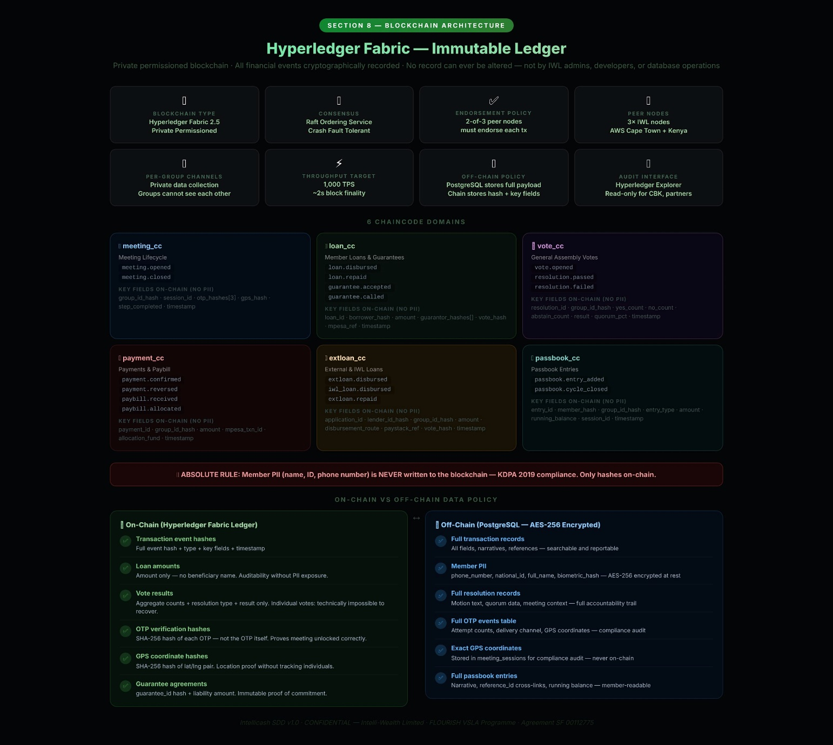

8.1 Hyperledger Fabric Network Configuration
Parameter | Configuration | Rationale
Blockchain Type | Hyperledger Fabric 2.5 (private permissioned network) | Regulated financial data; no public exposure; KDPA 2019 compatible; enterprise-grade
Consensus Mechanism | Raft ordering service (crash fault tolerant) | Suitable for AWS Kenya Region; tolerates up to n/2 node failures
Endorsement Policy | 2-of-3 peer nodes must endorse each transaction | Prevents single-node manipulation; remains available with 1 node offline
Peer Nodes | 3 × IWL peer nodes (AWS Africa — Cape Town + Kenya Region) | Geographic redundancy; Kenyan data sovereignty for at least 2 nodes
Channels | Separate private data collection per group | Groups cannot see each other's transaction data
Chaincode Language | Go (Golang) | Hyperledger recommended; performant; type-safe
Off-Chain Storage | PostgreSQL stores full payload; blockchain stores event type + hash + key fields only | Minimises on-chain data storage; PII stays off-chain always
Transaction Throughput | Target 1,000 TPS | Sufficient for all Kenya + East Africa VSLA transaction volume at scale
Audit Interface | Hyperledger Explorer (read-only web interface) | IWL Admin, CBK regulator, authorised partner can independently verify any transaction
Block Finality | ~2 seconds (Raft consensus) | Acceptable for VSLA meeting context; passbook entry visible within 5s

8.2 Chaincode Domains
Chaincode | Domain | Events Written | Key Fields On-Chain (no PII) | Trigger
meeting_cc | Meeting Lifecycle | meeting.opened meeting.closed | group_id_hash, session_id, otp_hashes[3], gps_hash, step_completed, timestamp | All 3 OTPs verified; meeting closed at Step 8
loan_cc | Member Loans & Guarantees | loan.disbursed loan.repaid loan.defaulted guarantee.accepted guarantee.called guarantee.discharged | loan_id, borrower_hash, amount, guarantor_hashes[], vote_hash, mpesa_ref, timestamp | Loan disbursement confirmed; repayment received; guarantee events
vote_cc | General Assembly Votes | vote.opened resolution.passed resolution.failed | resolution_id, group_id_hash, yes_count, no_count, abstain_count, result, quorum_pct, timestamp | Vote closed; result computed
payment_cc | Payments & Paybill | payment.confirmed payment.reversed paybill.received paybill.allocated | payment_id, group_id_hash, amount, mpesa_txn_id, paybill_txn_id, allocation_fund, timestamp | Payment webhook confirmed; Paybill received and matched
extloan_cc | External Loans & IWL Direct | extloan.disbursed iwl_loan.disbursed extloan.repaid | application_id, lender_id_hash, group_id_hash, amount, disbursement_route, paystack_ref, vote_hash, timestamp | External loan or IWL loan disbursed
passbook_cc | Passbook Entries | passbook.entry_added passbook.cycle_closed | entry_id, member_hash, group_id_hash, entry_type, amount, running_balance, session_id, timestamp | Each passbook entry written during active session; cycle close

8.3 On-Chain vs. Off-Chain Data Policy
Data Category | On-Chain (Fabric Ledger) | Off-Chain (PostgreSQL) | Compliance Rationale
Transaction event hashes | ✅ Full event hash + type + key fields + timestamp | ✅ Full record with all fields | Immutability on-chain; searchable/reportable off-chain
Member PII (name, ID, phone) | ❌ NEVER on-chain | ✅ AES-256 encrypted in PostgreSQL | KDPA 2019 right to erasure via anonymisation
Loan amounts | ✅ Amount only, no beneficiary name | ✅ Full loan record with borrower reference | Auditability without personal data exposure on ledger
Vote results | ✅ Aggregate counts + resolution type + result | ✅ Full resolution record | Individual vote privacy; only aggregates public
OTP verification hashes | ✅ Hash of each OTP (not the OTP itself) | ✅ otp_events table | Proves meeting unlocked correctly without exposing OTP
Guarantee agreements | ✅ guarantee_id hash + liability amount | ✅ Full loan_guarantees record | Immutable proof of commitment without PII
GPS coordinates | ✅ SHA-256 hash of lat/lng pair | ✅ Exact coordinates in meeting_sessions | Location proof without tracking individual positions
Paybill receipts | ✅ paybill_txn_id + amount + group_hash + timestamp | ✅ Full paybill_transactions record | Immutable custody proof for IWL Custodian account
Passbook entries | ✅ entry_id + entry_type + amount + member_hash + session_id | ✅ Full passbook_entries record with narrative | Tamper-proof ledger; PII stays off-chain

SECTION 9
Security Framework
Five-layer anti-manipulation model, separation of duties, and data protection

9.1 IWL Five-Layer Anti-Manipulation Framework
Layer | Physical VSLA Equivalent | Digital Implementation | Threat Prevented
1 — Identity | Members know each other personally | IPRS KYC + biometric login + group member photo verification at registration | Impersonation; phantom member registration; fake identity
2 — Three-Key Meeting Lock | Three padlocks on cashbox; three separate physical keys | 3-key OTP (6-digit SMS/USSD) + GPS geofence (50m); all three must pass; meeting hard-blocked if any fail | Meeting opened without all key-holders; single-officer control of funds; remote fraud
3 — Per-Transaction OTP | Member physically counts and receives money in front of group | Every M-Pesa STK Push debit and B2C credit requires a member OTP confirmation before execution | Silent unauthorised deductions; Treasurer unilateral fraud; ghost disbursements
4 — Real-Time Group Visibility | All transactions done in front of all members simultaneously | Live meeting ledger streamed to all member devices during active session in real time | Secret transactions; retroactive record manipulation; officer collusion
5 — Immutable Ledger | Passbook entries are permanent (red pen only for cancellations) | Append-only, blockchain-backed event ledger; no DELETE/UPDATE at any system layer, ever | Retroactive data fraud; cover-up of embezzlement; disputed transaction manipulation

9.2 System-Enforced Separation of Duties
Rule | Enforcement Method | Consequence of Violation Attempt
Chairperson cannot approve their own loan application | Loan Service: auto-assigns a different officer as approver if applicant is Chairperson | Hard block — system rejects action with error message; audit event logged
Chairperson cannot cast a deciding vote on their own motion | Vote Service: Chairperson's vote is accepted but recusal option is presented; result validated without their vote if outcome-determinative | Audit flag raised; IWL Admin notified if pattern repeated
Treasurer cannot confirm their own loan repayment | Loan Service: repayment confirmation requires a different officer OTP | Hard block; audit event logged
Treasurer cannot disburse to themselves without dual OTP | Payment Service: any B2C where recipient matches Treasurer's phone triggers dual officer OTP requirement | Hard block; additional audit event; IWL Admin alert
Key-Holders cannot be MC officers | Group Service: enforced at role assignment; checked at every OTP event | Hard block at formation and at any attempted role change
Loan cancellation requires dual officer sign-off | Loan Service: Chairperson + Treasurer both must provide OTP to cancel | Hard block; single-officer cancellation attempt logged as security event
IWL system admins cannot create or modify group financial records | API Gateway: admin JWT scopes exclude all write paths to group financial data | 403 Forbidden at gateway; audit event logged; IWL security team alerted
Partner API access is read-only | API Gateway: partner OAuth2 tokens have no write scopes; all write endpoints return 403 to partner tokens | 403 Forbidden; logged; webhook notification to partner admin on repeated attempts
Vote anonymity: no user can view individual ballots | Vote Service: individual votes encrypted client-side with member public key before transmission; server never receives plaintext ballot | Decryption technically impossible without member's private key

9.3 Data Protection & KDPA 2019 Compliance
Requirement | Implementation | Standard / Regulation
Encryption at rest | AES-256 for all PII fields (phone, national_id, biometric_hash, bank_account_no, sender_phone). Database-level encryption for all tables. | KDPA 2019 §25; IWL Data Protection Policy
Encryption in transit | TLS 1.3 for all API connections; certificate pinning on Mobile App; HSTS on Web Platform. | KDPA 2019 §25; CBK Cybersecurity Guidelines
Right to erasure | Anonymisation (not deletion) for transactional integrity. PII replaced with 'ANONYMISED' string. Financial records retained as required. Blockchain hashes remain (no PII on chain). | KDPA 2019 §26; CBK 7-year financial record retention
Data minimisation | Only collect fields necessary for VSLA operation. No marketing data. No behavioural analytics on members. | KDPA 2019 §25(c)
Consent at registration | Explicit opt-in consent form at account creation. Language: Kiswahili and English. Consent record stored immutably. | KDPA 2019 §30
DPO registration | IWL-registered Data Protection Officer with ODPC Kenya. Contact displayed in app. | KDPA 2019 §24
Breach notification | Incident Response Plan: system isolation within 1h; ODPC notification within 72h; affected member SMS within 24h of notification. | KDPA 2019 §43; ODPC Guidelines
Data residency | All operational data stored in AWS regions with at least one Kenya-resident node. | CBK Data Residency Guidelines 2022
Access controls | Role-based access control (RBAC) at API Gateway level. Principle of least privilege. IWL staff access audited monthly. | KDPA 2019 §25; ISO 27001
Penetration testing | Bi-annual third-party penetration testing. Results reported to IWL Board. Critical findings resolved within 30 days. | CBK Cybersecurity Guidelines; IWL Security Policy

SECTION 10
Payments & External Integrations
Payment rails, IWL Paybill, Paystack, and all third-party integrations

Intellicash is a payment pass-through. The platform never holds member funds as a financial institution. All funds flow through licensed payment providers (M-Pesa, Paystack, KCB Buni) or IWL's Custodian Account under IWL's operating licence. No financial transaction is permitted outside a Three-Key unlocked meeting session, except: Paybill deposits, Paystack repayments, and external loan repayments (which occur on scheduled dates, not meeting dates).

10.1 Payment Transaction Map
Transaction Type | Direction | Rail | Meeting Step / Trigger | Member OTP Required? | Blockchain Event
Fine collection | Member → Loan Fund | M-Pesa STK Push | Step 1 — Opening | Yes | payment.confirmed
Social Fund contribution | Member → Social Fund | M-Pesa STK Push | Step 3 — Social Fund | Yes | payment.confirmed
Social Fund grant disbursement | Social Fund → Member | M-Pesa B2C | Step 3 — post-GA vote | Yes (recipient) | payment.confirmed; grant.disbursed
Loan repayment | Member → Loan Fund | M-Pesa STK Push | Step 4 — Loan Repayments | Yes | loan.repayment.received
Share purchase | Member → Loan Fund | M-Pesa STK Push | Step 5 — Share Purchase | Yes | share.purchased
Internal loan disbursement | Loan Fund → Member | M-Pesa B2C | Step 6 — post-GA vote | Yes (borrower) | loan.disbursed
External loan repayment (per member) | Member → External Fund | M-Pesa STK Push | Post-meeting scheduled date | Yes | extloan.repayment_received
External loan receipt (bank/MFI) | Bank/MFI → External Fund | KCB Buni EFT or M-Pesa B2C | On lender approval | No (automated) | extloan.disbursed
IWL Direct Loan disbursement | IWL Lending Fund → Group | Paystack Transfer | On IWL Officer approval | No (automated to registered account) | iwl_loan.disbursed
IWL Direct Loan repayment | Group → IWL | Paybill or Paystack link | Scheduled repayment date | No (Paybill) / optional (Paystack) | iwl_loan.repayment_received
Paybill deposit (no bank acct groups) | Member/Treasurer → IWL Custodian | M-Pesa Paybill (522522) | Any time — not session-locked | No | paybill.received
Custodian fund allocation | IWL Custodian → Group Fund | Internal ledger transfer | Treasurer action, any time | No — Treasurer action in app | fund.credited
Share-out payout | Loan Fund → Members (batch) | M-Pesa B2C (batch) | Action Audit — Step 7 of Wizard | Yes (each member) | shareout.disbursed
Grant receipt | Donor/NGO → Grant Fund | EFT / KCB Buni | On partner approval — any time | No | grant.received
VSLF deposit | Group → Federation Pool | KCB Buni / M-Pesa | Post-meeting — on VSLF schedule | Treasurer OTP | payment.confirmed

10.2 IWL Paybill — Custodian Account
Attribute | Detail
M-Pesa Paybill Business Number | 522522
Account Reference Format | GRP-XXXXX (e.g., GRP-00445) — system-generated, unique per group
Beneficiary | IWL Custodian Account — ring-fenced sub-ledger per group reference
Who May Deposit | Any M-Pesa subscriber — members, non-members, external parties on behalf of group
Fund Allocation | Treasurer must allocate within 48h to: Loan Fund, Social Fund, External Loan Repayment, or IWL Loan Repayment
Unmatched Funds | Held in IWL unmatched holding account. IWL Finance investigates within 24h. Refunded via M-Pesa reversal if unresolvable.
Reversal Handling | M-Pesa reversal webhook handled by Paybill Service. Custodian balance debited. Treasurer notified. If already allocated: Fund Service reversal triggered.
Transition to Bank Account | When group opens a bank account: IWL Finance processes EFT of full custodian balance. Custodian sub-account closed. Future funds route directly to bank.
IWL Liability | IWL acts as custodian only. Funds held on trust for the group. IWL may not use custodian funds for its own operations.

10.3 Paystack Integration — IWL Direct Loans
Paystack API Endpoint | Purpose | IWL Business Rule
POST /transfer/initiate | Disburse IWL Direct Loan to group's registered M-Pesa or bank account | Only triggered after: (1) GA vote passed, (2) Credit Score ≥80, (3) IWL Loan Officer manual approval on Web Platform, (4) Group has no active IWL loan
GET /transaction/verify/:ref | Confirm disbursement status | Passbook entry and blockchain record created only on 'success' status from Paystack
POST /refund | Reverse erroneous disbursement | Requires dual IWL Officer sign-off. Reversal window: 24 hours. Blockchain records reversal event.
Webhook: charge.success | Receive card or bank repayments from groups | Updates loan_repayments record; triggers Guarantee Service discharge check; credit score recalculated
Webhook: transfer.failed | Handle failed outbound disbursement | IWL Loan Officer notified immediately; loan status = 'disbursement_pending'; IWL initiates M-Pesa B2C fallback or re-initiates Paystack
POST /subaccount | Create segregated sub-account per group for fund management | Sub-account created at IWL loan approval. All IWL loan funds routed through group's Paystack sub-account.

10.4 External Integrations
Integration | Provider | Purpose | Fallback
Mobile Money (C2B/B2C) | Safaricom M-Pesa Daraja v3 | STK Push, B2C payout, Paybill webhook, balance check, reversal, transaction status | Paystack (card payments) for select transactions; Cash Settlement Mode (see §13)
Payment Gateway | Paystack | IWL Direct Loan disbursements; card/bank repayments; sub-account management | M-Pesa B2C fallback for disbursements if Paystack unavailable
Banking API | KCB Buni API | Group bank accounts; bulk disbursement for external loans; account statements; loan application relay to KCB | EFT via SWIFT if Buni API unavailable; manual confirmation within 24h
National ID KYC | IPRS Kenya (Integrated Population Registration System) | Member National ID number + name verification at registration | Manual KYC hold: 'Pending Verification' status; document review within 48h by IWL staff
Credit Bureau | TransUnion CRB Africa | Member individual credit history check for external loan eligibility assessment | Skip check but flag in credit data package: 'CRB data unavailable at assessment'
SMS / USSD | Africa's Talking | OTP delivery, meeting reminders, arrears alerts, USSD fallback for feature phones | Emergency: IWL staff SMS via backup gateway (Twilio)
Market Prices | M-Farm Kenya | Live commodity prices for SPM+ business module members in agricultural VSLAs | Cached last-7-day prices served from BigQuery; prices labelled 'as of [date]'
Monitoring & Alerting | Grafana + Prometheus + Sentry | System health dashboards; API latency; payment success rates; error tracking; alerting | AWS CloudWatch as backup; PagerDuty for on-call escalation
Cloud Infrastructure | AWS (Africa — Kenya/Cape Town regions) | All compute, storage, networking, KMS key management, CI/CD | Multi-region within Africa; RTO 4h, RPO 1h

SECTION 11
UI Wireframes
Key screen layouts for developer reference — mobile-first (375px)

The wireframes below represent required screen layouts and component hierarchy. They are binding UX specifications, not suggestions. The design system uses IWL Green (#1B6B3A) as primary for all Member and Group Account screens, IWL Blue (#0D47A1) for Agent Accounts, and IWL Purple (#4A148C) for governance screens. All screens must support Kiswahili and English.

11.1 Onboarding — Account Type Selection


11.2 Group Account — OTP Meeting Activation
SCREEN: ACTIVATE MEETING [Group Account → Meetings → Start Meeting]
🗝 MEETING ACTIVATION
Unity Chama VSLA · Wednesday 7 May 2026 · 2:00 PM
Each Key-Holder must read their OTP aloud. Secretary enters it below.
Key-Holder | Name | Enter OTP | GPS Status | Result
Key-Holder 1 🗝 | Daniel Ochieng | [ _ _ _ _ _ _ ] → [VERIFY] | ✅ 18m | ⏳ Waiting
Key-Holder 2 🗝 | Akinyi Otieno | [ 4 8 2 9 1 7 ] → ✅ | ✅ 9m | ✅ VERIFIED
Key-Holder 3 🗝 | Mwangi Kamau | [ _ _ _ _ _ _ ] → [VERIFY] | ❌ 310m | ❌ OUT OF RANGE

📲 RESEND ALL OTPs | ✖ CANCEL MEETING

Meeting CANNOT start until all 3 OTPs are verified AND all 3 GPS checks pass.

11.3 Member Account — Personal Dashboard
SCREEN: MEMBER DASHBOARD [Member Account → Home]
👋 Habari Amina! | 🔔 2 Arifa

📊 My Shares (Total) | 💰 Loan Balance | 🤝 Guarantor Liability
KES 14,400 (36 stamps) | KES 8,000 due 15 Jun 2026 | KES 5,000 (Wanjiku's loan)

💳 Buy Shares | 📋 Apply for Loan | 🗳 Vote | 🤝 Guarantee Loan

📖 Recent Transactions
Date | Type | Amount | Status
07 May | Share Purchase ×2 | KES 800 | ✅ Confirmed
07 May | Social Fund | KES 100 | ✅ Confirmed
30 Apr | Loan Repayment | KES 2,000 | ✅ Confirmed

🏠 Home | 📅 Meetings | 👥 Members | 💰 Loans | ⋯ More

11.4 Group Account — External & IWL Loans Panel
SCREEN: GROUP FINANCE — EXTERNAL LOANS [Group Account → Group Finance → Loans]
🏦 Bank / MFI Loans | 🏢 IWL Direct Loans | 📋 Active Loans | 📊 History

📊 IWL Credit Score: 84 / 100 · Status: Credit Eligible ✅

Lender | Product | Max Amount | Rate | Term | Action
KCB Bank | VSLA Credit | KES 500,000 | 14% p.a. | 12 mo | [ APPLY ]
Equity MFI | Group Loan | KES 300,000 | 18% p.a. | 6 mo | [ APPLY ]
🏢 IWL Direct | IWL VSLA Loan | KES 200,000 | 12% p.a. | 9 mo | [ APPLY ]
AMREF MFI | Agri-Group | KES 150,000 | 16% p.a. | 6 mo | [ APPLY ]

Applying triggers a GA vote (75% Yes required). Application cannot proceed without a successful vote.

11.5 Group Account — Paybill Savings Screen
SCREEN: PAYBILL SAVINGS [Group Account → Finance → Paybill Deposits]
📱 Save via M-Pesa Paybill
For groups without a bank account
Paybill Business Number | Your Group Account Reference | Group Name
522522 | GRP-00445 | Unity Chama VSLA

How to Pay (Jinsi ya Kulipa):
- Open M-Pesa → Lipa Na M-Pesa → Pay Bill
- Business No: 522522
- Account No: GRP-00445
- Enter amount and confirm with M-Pesa PIN

💰 Custodian Balance | ⏳ Unallocated Deposits | 📅 Last Deposit
KES 47,200 | KES 5,000 (needs allocation) | 07 May 2026 — KES 2,000

📂 Allocate to Loan Fund | 📂 Allocate to Social Fund | 📂 Repay External Loan

11.6 Member Account — Credit Guarantee Request
SCREEN: LOAN GUARANTEE REQUEST [Member Account → 🔔 Notification → Guarantee Request]
🤝 You Have Been Asked to Guarantee a Loan

Borrower | Loan Amount | Purpose | Term | Your Liability if Default
Amina Wanjiku | KES 12,000 | Secondary school fees | 3 months | KES 12,000 (full — you are sole guarantor)

⚠ If Amina defaults on this loan, KES 12,000 will be deducted from your share balance at Share-Out. This commitment is recorded permanently on the blockchain.

✅ ACCEPT GUARANTEE | ❌ DECLINE

Active Guarantees I Hold:
Borrower | Amount | Status | Due
Wanjiku Njoroge | KES 5,000 | Active — repaying | June 2026

11.7 Agent Account — CBT Caseload Dashboard
SCREEN: AGENT DASHBOARD [Agent Account → CBT Module → Caseload]
🤝 Peter Kamau · Village Agent · Embu North Sub-County
📋 Caseload: 14 Groups · 3 overdue visits · 1 pending phase advancement
Group | Phase | Last Visit | Quality | Next Visit Due | Action
Unity Chama | Intensive | 07 May | 87% | 14 May | [ LOG VISIT ]
Imani VSLA | Development | 22 Apr | 91% | 20 May | [ LOG VISIT ]
Tumaini Chama | Mobilisation | 07 May | N/A | 08 May | [ FORMATION ]
Umoja Group | Maturity | 01 Apr | 78% ⚠ | 01 May ❌ OVERDUE | [ VISIT NOW ]

➕ Form New Group | 📋 Training Modules | 🌐 VAN Network | 📊 My Performance

11.8 Web Platform — Partner Portfolio Dashboard
WEB SCREEN: PARTNER PORTFOLIO [Web Platform → Portfolio Overview]
📊 AMREF Programme Portfolio · Embu & Kirinyaga Counties · Live Data
KPI | Value | vs. Last Month | Status
Total Groups | 47 | ↑ +2 | ✅
Total Members | 1,128 | ↑ +51 | ✅
Total Savings (KES) | 3,842,000 | ↑ +12% | ✅
Active External Loans | 8 groups | — No change | ✅
Average Repayment Rate | 94.2% | ↑ +1.3% | ✅
Groups with Credit Score ≥75 | 31 | ↑ +3 | ✅
Groups Currently in Meeting | 3 | Live now | 🔴 Live

📋 Group Intelligence | 📡 Live Meetings | 💳 Credit Pipeline | 📈 MEL Reports | ⚙ Settings

SECTION 12
IWL Credit Score & External Finance
Group creditworthiness model, external loan pipeline, and VSLF federation

12.1 IWL Credit Score Algorithm
The IWL Credit Score is a proprietary creditworthiness metric computed for every VSLA group after every meeting.closed event. It ranges from 0 to 100. The score is the primary gateway to external credit access and VSLF federation. It is computed entirely from data generated within Intellicash — no manual input, no subjective assessment.
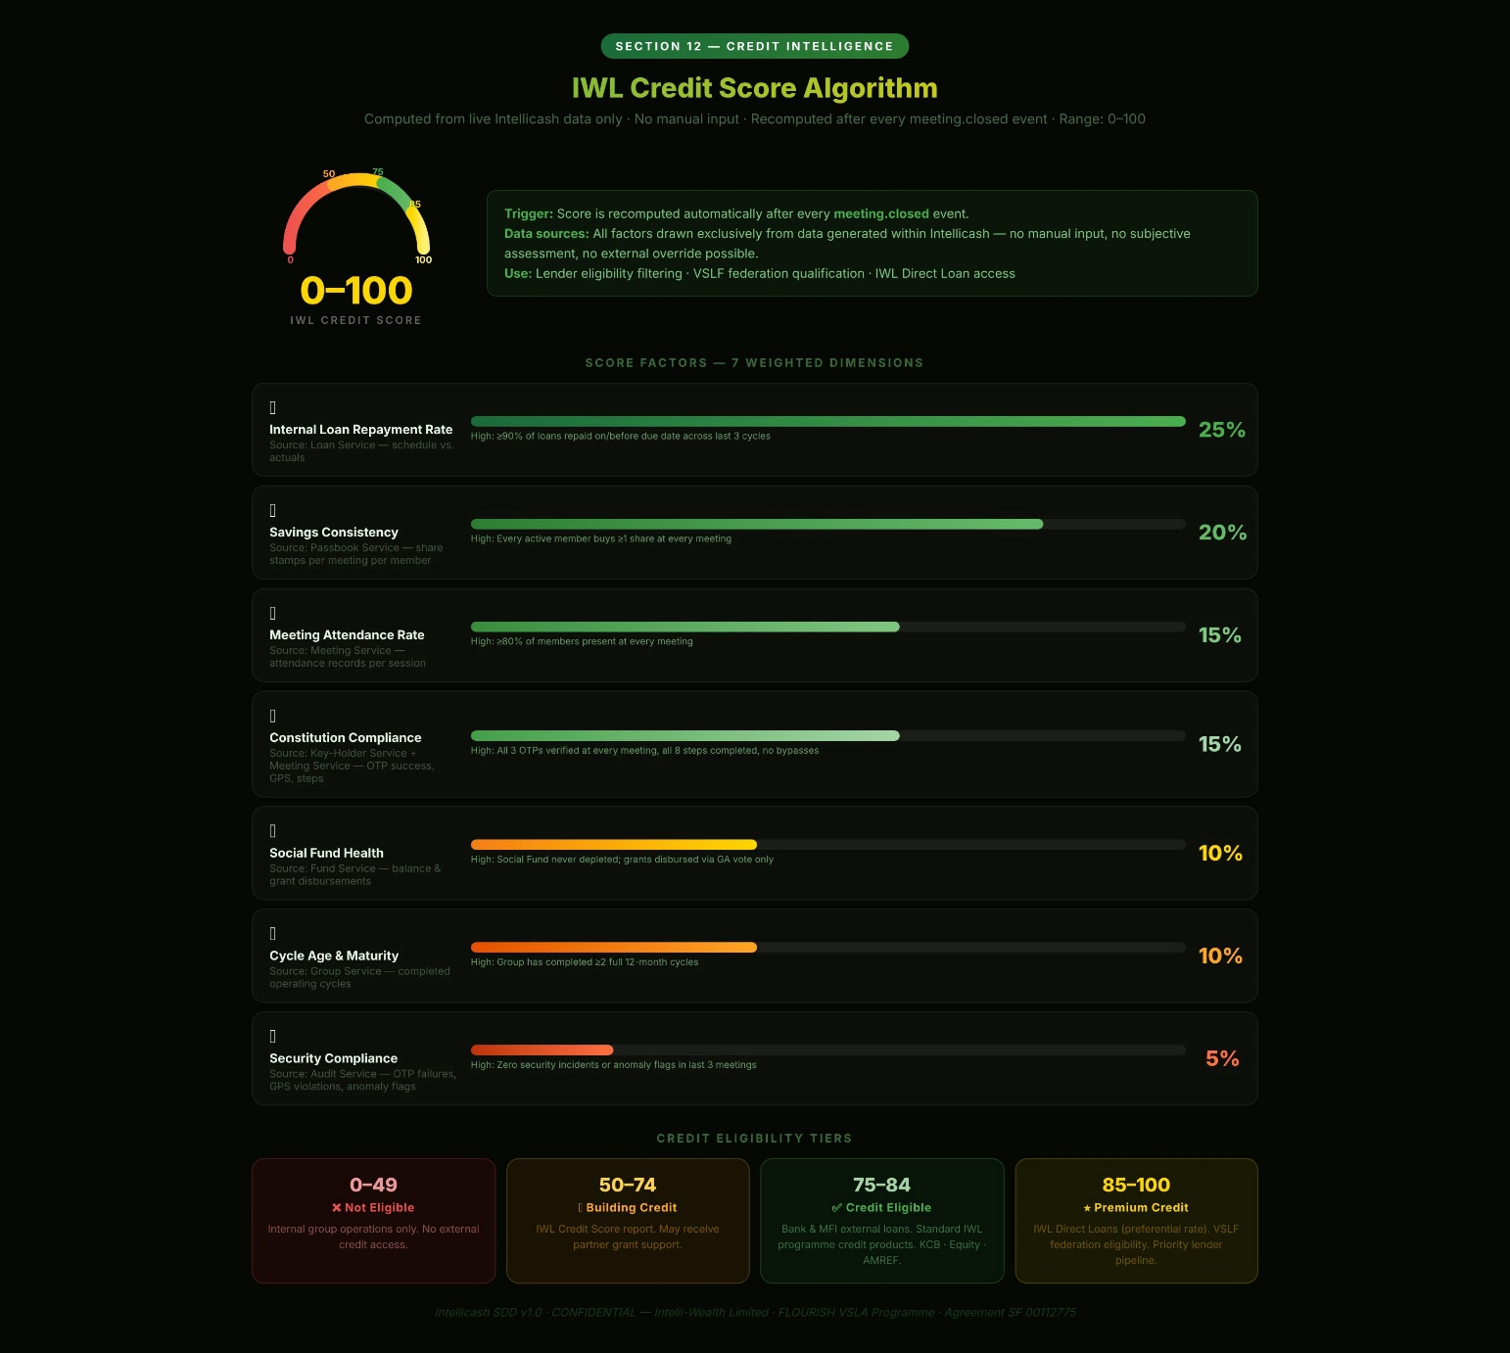

Factor | Weight | Data Source | What a High Score Means
Internal Loan Repayment Rate | 25% | Loan Service — repayment schedule vs. actuals | ≥90% of loans repaid on or before due date in last 3 cycles
Savings Consistency | 20% | Passbook Service — share stamps per meeting per member | Every active member buys at least 1 share every meeting
Meeting Attendance Rate | 15% | Meeting Service — attendance records per session | ≥80% of members present at every meeting
Constitution Compliance | 15% | Key-Holder Service + Meeting Service — OTP success rate, GPS compliance, step completion | All 3 OTPs verified at every meeting; all 8 steps completed; no bypasses
Social Fund Health | 10% | Fund Service — Social Fund balance; grant disbursements | Social Fund never depleted; grants disbursed by GA vote only
Cycle Age & Maturity | 10% | Group Service — number of completed operating cycles | Group has completed ≥2 full 12-month cycles
Security Compliance | 5% | Audit Service — OTP failures, GPS violations, anomaly flags | Zero security incidents or anomaly flags in last 3 meetings

Score Range | Credit Eligibility | Available Products
0–49 | Not eligible | Internal group operations only; no external credit access
50–74 | Building credit | Eligible for IWL Credit Score report; may receive partner grant support
75–84 | Credit eligible | Bank and MFI external loan applications; standard IWL programme credit products
85–100 | Premium credit | IWL Direct Loans at preferential rate; VSLF federation eligibility; priority lender pipeline

12.2 External Loan Pipeline (Web Platform)
The Credit Pipeline module on the Web Platform allows authorised banks and MFIs to view credit-eligible groups, filter by score, phase, county, and loan history, and access a one-click credit data package. This is a read-only, API-driven view — the platform never exposes group-level write actions to lenders.

Data in Credit Package | Source | Immutability
IWL Credit Score (current + 12-month trend) | Credit Score Service | Computed from blockchain-verified data; cannot be manually inflated
Meeting attendance history (last 12 meetings) | Meeting Service passbook | Blockchain-verified timestamps and GPS compliance
Savings trend (12-month aggregate) | Passbook Service | Append-only passbook; blockchain-backed
Internal loan repayment record (all cycles) | Loan Service | Append-only; defaulted loans visible — cannot be hidden
Constitution (current version with amendment history) | Group Service | SHA-256 hashed at each version; immutable
Group phase and cycle count | Group Service | Agent sign-off and Admin counter-sign required for phase changes
External loan repayment history | External Finance Service | Blockchain-backed; all defaults visible to all authorised lenders

12.3 VSLA Federation (VSLF)
VSLF Feature | Description | Eligibility
VSLF Membership | Groups join a federation pool to access larger collective credit tranches | Credit Score ≥85; ≥2 completed cycles; GA vote (75%); IWL Admin approval
Collective Loan Access | Federation applies as a collective to banks/MFIs; risk spread across member groups | All member groups must be Credit Score ≥75 at time of collective application
VSLF Deposit | Groups deposit a portion of their Loan Fund into the VSLF pooled account via KCB Buni | Minimum deposit: 10% of Loan Fund balance; maximum: 50%
Inter-Group Lending | Federation may on-lend to member groups from the pooled account at VSLF rates | Governed by VSLF constitution; requires VSLF committee vote; tracked in External Finance Service

SECTION 13
Risk Register & Contingency Plans
All known platform risks with mitigation strategies and fallback protocols

Every risk below has two responses: a Primary Mitigation (what the platform does to prevent or reduce the risk) and a Contingency Plan (the fallback protocol to be activated if mitigation fails or is insufficient). The contingency plans are binding operational procedures — they must be implemented in the platform and in IWL operational protocols. Risk ratings: Likelihood H=High M=Medium L=Low. Impact C=Critical H=High M=Medium.

Risk | Platform | Likeli-hood | Impact | Primary Mitigation | Contingency Plan (Fallback)
IWL methodology drift — platform features contradict IWLSGS | Both | M | C | Monthly methodology compliance audit; IWLSGS clauses encoded and locked in platform logic; cannot be disabled by any user role | Emergency feature flag disables offending function; IWLSGS review board convened within 48h; rollback deployed via forced app update to all devices
Low smartphone penetration — members cannot access Mobile App | Mobile | H | H | USSD channel (Phase 6); shared-device group model; CBT/VA acts as proxy device holder during meetings | Accelerate USSD delivery to Phase 3; negotiate device financing with Safaricom/KCB; paper-to-digital bridge mode retains paper passbooks alongside digital ledger
No mobile connectivity at meeting location — offline meeting needed | Mobile | H | H | IWL Sync Engine: full offline capability for all 8 steps; OTPs pre-cached; M-Pesa payment queue on reconnect | Manual Override Protocol: meeting recorded on paper; Secretary digitises within 24h; dual officer OTP signs off manual entry; anomaly logged to audit trail
Member distrust of digital system vs. physical cashbox | Mobile | H | M | CBT training programme; demo mode; gradual paper-to-digital transition; parallel paper + digital running period | Extend parallel period from 1 to 3 months; VA escalates persistent trust issues to IWL Admin; group may petition for extended hybrid mode via GA vote
OTP SMS delay or non-delivery in rural areas | Mobile | H | H | USSD OTP fallback delivery via Africa's Talking; OTPs pre-cached when device has signal | If both SMS and USSD fail: IWL Admin activates Manual Override Protocol with mandatory audit note; session_id created manually; blockchain entry includes override flag
Three Key-Holder collusion to open meeting fraudulently | Mobile | L | H | All-member real-time ledger visibility during meeting; GPS independent verification; anomaly detection in Audit Service; partner dashboard alerts | Automatic meeting freeze on anomaly detection; IWL Admin and partner alerted via Web Platform; forensic audit of session logs; group placed on Enhanced Monitoring; key-holders replaced via emergency GA vote
M-Pesa API downtime during active meeting | Mobile | M | H | Payment queue + retry engine; meeting continues with manual recording in app; auto-reconciliation on reconnect | If downtime >2h: Treasurer activates Cash Settlement Mode — transactions recorded digitally with 'Pending Payment' status; members acknowledge in-app; all payments processed within 24h on reconnect; reconciliation report generated and partner-visible
External loan group default cascading to members | Both | M | H | Conservative IWL credit threshold (≥75 required); lender holds credit risk, not IWL; external fund completely segregated from internal fund | Default Early Warning System: repayment rate <70% triggers auto-alert to IWL Admin, partner, and VA; escalation visit within 5 days; loan restructuring workflow offered; if default confirmed, share-out suspended; legal protocol per IWL constitution
IWL Direct Loan default — Paystack disbursement unrecoverable | Both | M | H | Credit score ≥80 gate; GA vote required; IWL Officer manual review; Guarantee Service calls guarantees on default | Arrears flag at Day 7; credit score penalised from Day 1; IWL Loan Officer initiates restructuring; legal debt recovery per IWL Loan Agreement if restructuring fails; write-off requires IWL Board approval and audit log entry
Paybill unmatched deposits — wrong account reference | Both | H | M | Clear paybill reference format (GRP-XXXXX) displayed prominently; confirmation SMS with group name | Unmatched funds held in IWL holding account; IWL Finance investigates within 24h; refunded via M-Pesa reversal if unresolvable within 72h; all unmatched events reported to IWL CFO weekly
Guarantor cannot cover called guarantee at share-out | Mobile | M | H | Guarantor passbook flagged immediately on acceptance; guarantor cannot receive own share-out until guarantee resolved | Guarantor's share-out held in escrow; borrower given 30-day cure period; if uncured: guarantor's escrow applied; any residual written off with GA vote and documented in audit log; credit score impact for both borrower and guarantor
Vote manipulation via social pressure despite anonymity | Mobile | L | M | Ballot encryption enforced; no officer can view individual votes; result hashed immediately | If result disputed: any member can raise formal objection in-app within 24h; anonymised audit (counts only) reviewed by IWL Admin; if irregularity confirmed, re-vote within 7 days facilitated by VA
CBK regulatory non-compliance (PSSP licensing) | Both | M | C | Early CBK engagement; sandbox licence in process; pass-through model (IWL never holds funds as financial institution); CBK-aligned transaction reporting | Platform operates in restricted mode: no direct M-Pesa B2C; all disbursements via KCB Buni as licensed intermediary; operations paused for non-compliant types until licence confirmed; compliance counsel engaged
Blockchain node failure or compromise | Both | L | C | 3-node Raft consensus with 2-of-3 endorsement; geographic node separation; bi-annual penetration testing | If 1 node compromised: 2-of-3 endorsement maintains operation; compromised node isolated; IWL security team forensic review within 4h; node rebuilt from backup; all transactions validated against remaining nodes; CBK notified if data integrity at risk
Member personal data breach | Both | L | C | AES-256 encryption; bi-annual penetration testing; KDPA compliance; minimal PII collection; IWL DPO oversight | Breach Response Plan: system isolation within 1h; IWL DPO notified immediately; ODPC notified within 72h; affected members notified via SMS; forensic audit within 48h; partner notification via Web Platform; affected credentials reset; public disclosure per KDPA Article 43 if threshold breached
Sync conflict corrupting group ledger after offline meeting | Mobile | L | C | CRDTs ensure conflict-free merge; append-only ledger; server always authoritative for blockchain-signed entries | If conflict detected: affected meeting record flagged 'Conflict Detected'; IWL Admin alerted on Web Platform; conflicting entries presented to Treasurer + Chairperson for manual adjudication within 48h; dual officer OTP required to resolve; passbooks locked read-only until resolved
VA digital literacy gap — agent cannot operate CBT Module | Mobile | H | M | CBT App icon-first design; audio prompts; Kiswahili; IWL VA digital training before field deployment | If VA fails digital literacy threshold: 2-week hands-on coaching by IWL Master Trainer; VA shadowing experienced VA for first 3 groups; minimum score gate enforced before VA can advance groups to Intensive Phase
Key third-party API failure (M-Pesa / IPRS / KCB) | Mobile | M | H | Redundant API providers; Paystack as M-Pesa fallback for card payments; retry logic with exponential backoff | M-Pesa outage → Paystack; IPRS outage → manual KYC hold ('Pending Verification', full access within 48h); KCB outage → defer external disbursements; all fallback states logged and partner-visible on Web Platform status page
IWL Custodian account misused by IWL for own purposes | Both | L | C | Fund ring-fencing enforced at DB and service level; custodian balance tracked separately; monthly independent audit; partner-visible on Web Platform | If misuse suspected: immediate forensic audit by IWL Board; external auditor engaged; custodian balance verified against M-Pesa transaction history; affected groups notified; regulatory report to CBK if confirmed

SECTION 14
REST API Specification
OpenAPI 3.0 endpoint reference for partners, banks, and integrators

Intellicash exposes a REST API v1 (OpenAPI 3.0) documented at api.intellicash.co.ke. All partner access is via OAuth2 client credentials scoped to their programme groups. All endpoints are read-only for external partners. Write access is reserved for the Mobile App and Web Platform. IWL owns and controls the specification.

14.1 Groups & Portfolio Endpoints
Method | Endpoint | Description | Auth / Scope
GET | /v1/groups | List all VSLAs in partner scope; filter by phase, credit_score, county, GPS compliance, VSLF, external_loan_status | OAuth2 — partner scope
GET | /v1/groups/{id} | Full group profile: constitution, member count, phase, GPS, VA, IWL credit score, cycle | OAuth2 — partner scope
GET | /v1/groups/{id}/meetings | Meeting history: dates, attendance, 3-key status, step completion, transaction totals | OAuth2 — partner scope
GET | /v1/groups/{id}/ledger | Aggregate ledger: savings, loan book, Social Fund, External Fund, repayment rate | OAuth2 — partner scope
GET | /v1/groups/{id}/passbook/{memberId} | Individual passbook: stamps, loans, Social Fund history, share-out (scoped — partner must have member consent) | OAuth2 — partner scope + member consent
GET | /v1/groups/{id}/credit-score | IWL Credit Score (0–100), factor breakdown, 6-month trend, eligibility flags | OAuth2 — lender scope
GET | /v1/groups/{id}/external-finance | External loans, IWL direct loans, grants, VSLF status, repayment records | OAuth2 — lender scope
GET | /v1/groups/{id}/votes | All resolutions: motion, type, result, quorum compliance, blockchain hash, date | OAuth2 — partner scope
GET | /v1/portfolio | Aggregate portfolio KPIs: total savings, members, repayment rate, phase distribution, security compliance for partner scope | OAuth2 — partner scope

14.2 MEL & Reporting Endpoints
Method | Endpoint | Description | Auth / Scope
GET | /v1/analytics/mel-report | MEL export with 47 indicators; filterable by date range, county, phase | OAuth2 — partner scope
GET | /v1/analytics/cbts | VA performance: visit compliance, quality scores, group phase distribution, VAN activity | OAuth2 — partner scope / IWL Admin
GET | /v1/analytics/credit-pipeline | Groups eligible for external lending; filterable by score threshold, phase, county | OAuth2 — lender scope
GET | /v1/audit/events | Security audit log: OTP failures, GPS violations, anomaly flags (IWL Admin only) | OAuth2 — IWL Admin scope
POST | /v1/webhooks/subscribe | Register webhook URL for VSLA lifecycle event push notifications | OAuth2 — partner scope
DELETE | /v1/webhooks/{id} | Unsubscribe a webhook endpoint | OAuth2 — partner scope

14.3 Webhook Events
Event | Trigger | Payload Fields | Partner Use Case
group.phase_advanced | Group lifecycle phase changes | group_id, old_phase, new_phase, timestamp | NGO monitoring; programme milestone reporting
meeting.closed | Meeting Step 8 completed | group_id, session_id, attendance_count, total_savings, total_loans, timestamp | Real-time portfolio dashboard updates
loan.disbursed | Internal loan M-Pesa B2C confirmed | group_id, loan_id, amount, vote_hash, timestamp | Partner loan portfolio monitoring
extloan.disbursed | External loan or IWL loan disbursed | group_id, application_id, lender_type, amount, timestamp | Bank/MFI loan confirmation; IWL Finance alert
credit_score.threshold_crossed | Credit Score crosses 75 or 85 | group_id, old_score, new_score, threshold_crossed, timestamp | Bank/MFI eligibility notifications
loan.defaulted | Loan marked as defaulted by arrears engine | group_id, loan_id, principal_outstanding, guarantors_count, timestamp | Partner early warning; lender alert
share_out.completed | Action Audit Share-Out finalised | group_id, cycle_number, total_disbursed_kes, member_count, timestamp | Programme cycle completion reporting
group.created | New VSLA group activated by IWL Admin | group_id, county, phase, agent_id, timestamp | Portfolio growth tracking; MEL baselines

SECTION 15
Implementation Roadmap
Phased build plan — Month 0 to Month 30

This roadmap is binding. All features listed in a phase must be delivered and tested before the next phase begins. No phase may be skipped. IWL Executive Director must formally sign off each phase before development on the subsequent phase commences.

Phase | Scope | Key Milestone | Dependencies
Phase 0 Foundation | IWLSGS v1.0 finalisation; tri-account onboarding architecture sign-off; Hyperledger Fabric network setup (3 nodes); PostgreSQL schema design; API Gateway configuration; AWS Kenya Region provisioning; GitHub Actions CI/CD pipeline | Architecture, spec, and infrastructure signed off by IWL Executive Director | None — this is the foundation
Phase 1 Core Group & Identity | Identity Service; Group Service; Group Formation Wizard (Agent Account); Member Registration + IPRS KYC; IWL Sync Engine (offline SQLite + CRDT merge); CBT Module — Formation phase; Blockchain Service (meeting_cc + passbook_cc chaincodes) | First IWL VSLA group registered digitally; first member passbook created | Phase 0 infrastructure live; IPRS API access confirmed; Africa's Talking SMS
Phase 2 Meeting Workflow | Key-Holder Service + Three-Key OTP Protocol; 8-Step Meeting Workflow Engine; Digital Passbook; M-Pesa STK Push (basic C2B for shares, social fund, fines); Meeting Service; Passbook Service (append-only, blockchain-backed); OTP-Activated Meeting fully live | First fully digital IWL meeting conducted with Three-Key protocol | Phase 1 complete; M-Pesa Daraja v3 sandbox access; Africa's Talking USSD fallback
Phase 3 Loans & Governance | Loan Service + internal loan workflow; Credit Guarantee Service; Vote Service (anonymous ballot + blockchain hash); Social Fund (full); M-Pesa B2C disbursements; Fund Service (full 3-namespace); Share-Out Wizard v1; Partner Web Platform v1 (read-only portfolio); Blockchain Service (loan_cc + vote_cc chaincodes) | First internal loan disbursed via GA vote; first anonymous ballot; partners view live data on Web Platform | Phase 2 complete; M-Pesa Daraja v3 production access; KCB Buni API sandbox
Phase 3.5 Paybill Custodian | Paybill Service; M-Pesa Paybill C2B webhook; IWL Custodian Account sub-ledger; Group Account Paybill savings screen; Treasurer allocation workflow; Blockchain (payment_cc chaincode for paybill events) | First group deposit via Paybill; first Treasurer allocation to fund | M-Pesa Paybill business number 522522 registered; Phase 3 Fund Service live
Phase 4 External Finance | External Finance Service; External Loan Module (Bank/MFI pipeline); IWL Credit Score Service (full 7-factor algorithm); IWL Direct Loan Service (Paystack integration); Paystack Loan Service; Credit Pipeline on Web Platform; KCB Buni external loan integration; Blockchain (extloan_cc chaincode); VSLF federation module | First external loan facilitated; first IWL Direct Loan disbursed via Paystack; credit score visible to lenders on Web Platform | Phase 3 complete; Paystack API production access; KCB Buni API production; Credit Score model trained on Phase 1–3 data
Phase 5 API & Advanced Analytics | REST API v1 (OpenAPI 3.0); Webhook system (all events); API Developer Portal on Web Platform; Analytics Service (47 MEL indicators); MEL report exports (PDF/Excel); SPM+ business modules; IWL Admin system configuration modules; Partner API onboarding | API live with first partner MIS integration; all 47 MEL indicators reporting | Phase 4 complete; BigQuery data warehouse provisioned with Phase 1–4 data
Phase 6 USSD & Inclusion | USSD channel for feature phones (Africa's Talking); Microinsurance linkage; Gender sub-wallet reporting; M-Farm market price feeds; Accessibility improvements (enhanced audio prompts); Multi-language expansion (Dholuo, Kikuyu) | Feature phone users can participate in VSLA meetings via USSD; first microinsurance product offered | Phase 5 complete; Africa's Talking USSD production integration
Phase 7 East Africa Expansion | Uganda, Tanzania, Ethiopia regulatory compliance; Multi-language (Luganda, Swahili variants, Amharic); Cross-border VSLF lending; Multi-currency ledger; Country-specific KYC (NIRA Uganda, NIDA Tanzania) | First non-Kenya VSLA group registered; East Africa platform operational | Phase 6 complete; regulatory approval in target countries; partnerships with in-country MNOs

SECTION 16
Web Platform Specifications
Module map, access control, and feature requirements

16.1 Web Platform Module Map
Module | Available To | Core Features | Data Sources
Portfolio Overview | Partner Officers, IWL Admin | Aggregate KPIs for all programme groups; groups by phase; total savings trend; repayment rate; OTP/GPS compliance rate; live meeting count | Analytics Service; Meeting Service; Credit Score Service
Group Intelligence | Partner Officers, IWL Admin | Per-group scorecard: phase, meeting cadence, savings trend, loan book performance, IWL Credit Score history (12-month trend); officer roster | Group Service; Credit Score Service; Passbook Service
Live Meeting Monitor | Partner Officers, IWL Admin | Groups currently in session; 3-key unlock status; GPS compliance; running transaction totals; step progress; real-time alerts for anomalies | Meeting Service; Key-Holder Service; Audit Service
Credit Pipeline | Banks, MFIs, IWL Admin | Groups eligible for external lending (credit score filter); per-group credit data package; one-click loan application intake; active loan tracker | Credit Score Service; External Finance Service
IWL Loan Management | IWL Loan Officers, IWL Admin | IWL Direct Loan application queue; officer review and approval; Paystack disbursement initiation; repayment monitoring; arrears management | Paystack Loan Service; External Finance Service
Grant & External Loan Management | Partner Officers, IWL Admin | All external loan and grant applications by status; approval workflow; disbursement tracking; repayment schedules; partner reporting | External Finance Service; Fund Service
CBT Performance | Partner Officers, IWL Admin | VA visit compliance; quality score trends; groups at risk; VA caseload distribution; VAN activity; phase advancement log | CBT Service; Group Service
MEL & Impact Reports | Partner Officers, IWL Admin | 47 IWL standard MEL indicators; customisable indicator sets; automated PDF/Excel/CSV export; API feed; historical trend charts | Analytics Service; BigQuery
Security & Audit Log | IWL Admin only | OTP failure log; GPS out-of-range alerts; constitution deviation flags; failed transaction attempts; AML flags; immutable audit trail search | Audit Service; Blockchain Explorer
Votes & Governance | Partner Officers, IWL Admin | All resolutions: type, motion, result, quorum compliance, blockchain hash; officer election history; constitution version history | Vote Service; Group Service
Partner Administration | IWL Admin only | Partner onboarding; OAuth2 API key management; data scope configuration; webhook subscriptions; sandbox environment management | Identity Service; API Gateway config
VA & CBT Onboarding | IWL Admin only | VA registration; caseload assignment; digital literacy assessment scores; training records; performance dashboard | CBT Service; Identity Service
System Configuration | IWL Admin only | IWLSGS version management; constitution templates; service charge defaults; GPS radius defaults; regulatory report generation; feature flags | All services — config namespace
API Developer Portal | Partner Officers, Developers | OpenAPI 3.0 interactive documentation; sandbox environment; webhook testing console; OAuth2 client management; rate limit monitoring | API Gateway; Analytics Service

SECTION 17
Glossary
Definitive terminology for Intellicash v1.0

Term | IWL Definition
Action Audit | IWL's end-of-cycle full audit and share-out ceremony; digitised as the Share-Out Wizard in the Mobile App
Agent Account | Intellicash account type for Village Agents / CBTs and IWL staff. Provides CBT Module, caseload management, group formation, and (for IWL staff) loan officer functions.
Blockchain Service | Intellicash microservice wrapping Hyperledger Fabric. Receives async financial events via Kafka; commits immutable transaction hashes; returns confirmation hashes to originating services.
CBT | Community-Based Trainer — IWL field facilitator who forms and trains VSLAs; also called Village Agent (VA).
Credit Guarantee | Formal commitment by one or more VSLA members to repay a fellow member's loan if that member defaults. Recorded on blockchain; reflected on guarantor passbook as contingent liability.
Credit Score Service | Microservice computing IWL Credit Score after every meeting.closed event using 7 weighted factors from live group data.
Custodian Account | IWL-managed M-Pesa Paybill sub-account holding VSLA savings for groups without bank accounts. Funds are ring-fenced per group reference; IWL acts as custodian, not beneficial owner.
External Loan Sub-Account | Segregated fund namespace within the Group Account for bank/MFI external loan receipts. Never commingles with Internal Loan Fund or Social Fund.
Fund Service | Microservice managing three group fund namespaces: loan_fund, social_fund, external_fund. No cross-namespace transfer without explicit Treasurer action + dual officer OTP.
General Assembly (GA) | Full membership of a VSLA; the supreme governing body. All major decisions require a GA vote conducted during an active Three-Key unlocked meeting session.
Grant Fund | Segregated fund namespace for non-repayable grant receipts from NGO/donor/government partners. Purpose-locked; every disbursement requires GA vote; partner-visible on Web Platform.
Group Account | Intellicash account type representing a VSLA group entity. Used by officers and key-holders to manage meetings, funds, external loans, Paybill savings, and GA votes.
Guarantee Service | Microservice managing the lifecycle of credit guarantees: nomination, acceptance, active liability tracking, calling on default, and discharge on full repayment.
Hyperledger Fabric | Enterprise-grade private permissioned blockchain used by Intellicash for immutable financial event records. Separate channel per group; off-chain data storage with on-chain hash verification.
IWL Credit Score | Proprietary IWL creditworthiness algorithm (0–100) computed after every meeting. Used to determine eligibility for external loans, IWL Direct Loans, and VSLF federation.
IWL Direct Loan | A loan product offered directly by Intelli-Wealth Limited to qualifying VSLA groups (Credit Score ≥80). Disbursed via Paystack Transfer; governed by mandatory GA vote; repaid via Paybill or Paystack link.
IWL Sync Engine | IWL proprietary offline-first synchronisation layer. Uses CRDTs for conflict-free merge on reconnect. Enables full 8-step meeting operation without internet connectivity.
IWLSGS | IWL Savings Group Standard — IWL's proprietary VSLA methodology specification. Every Intellicash feature must map to an IWLSGS procedure.
Key-Holder | One of three designated VSLA members who each receive one OTP for meeting activation. Key-Holders cannot simultaneously hold MC officer roles (system-enforced).
Loan Fund | Internal fund namespace accumulating member share purchases, fines, and interest. Only disbursed as internal member loans; governed by 3× savings cap; separate from Social Fund.
Management Committee (MC) | Five elected group officers: Chairperson, Secretary, Treasurer, Money Counter 1, Money Counter 2. None may serve as Key-Holder.
Member Account | Intellicash account type for individual VSLA members. Provides passbook view, share purchase, loan application, anonymous voting, and loan guarantee functions.
OTP | One-Time Password — 6-digit code generated by CSPRNG; delivered via SMS or USSD; used for meeting Three-Key activation and individual transaction confirmation.
Operating Cycle | One full 12-month VSLA year, ending at Action Audit and Share-Out. Group cycle counter increments on Share-Out completion.
Passbook Service | Microservice maintaining each member's append-only personal ledger: share stamps, loan records, Social Fund history, and Share-Out archive. Backed by blockchain.
Paybill Service | Microservice processing M-Pesa Paybill (Business No. 522522) C2B webhooks; matching account references to groups; crediting custodian sub-accounts; alerting Treasurers.
Paystack Loan Service | Microservice managing IWL Direct Loan lifecycle: group application, IWL officer review queue, Paystack disbursement API, and repayment reconciliation.
Resolution | A motion put to a GA vote during an active meeting session. Types include loans, grants, elections, constitution changes, expulsions, and external loan approvals.
Service Charge | IWL term for loan interest; expressed as flat % per month × loan term (not compound). Set in group constitution.
Share | Unit of member savings; member buys 1–5 shares per meeting. Loan ceiling = 3× share value. Share value is the share denomination set in group constitution.
Share-Out | Distribution of accumulated savings plus returns to members at Action Audit. Disbursed via M-Pesa B2C batch. Requires GA vote to approve schedule.
Social Fund | Emergency grant pool; fixed member contribution per meeting; grants only (never loans); GA vote required for every disbursement.
Three-Key Protocol | The digital equivalent of IWL's physical three-padlock cashbox system. All 3 Key-Holders must verify via OTP and GPS before any meeting session can open.
Tri-Account Onboarding | The first-launch screen where every new user selects one of three account types: Member, Group, or Agent. This choice is permanent and determines all UI paths and permissions.
VAN | Village Agent Network — peer network of IWL VAs for post-project sustainability, mutual support, and cross-group learning.
VSLF | VSLA Federation — IWL wholesale credit model: groups pool capital collectively to access external credit at better terms.
Web Platform | Browser-based Intellicash application (Next.js) serving Partner Officers, Banks/MFIs, and IWL Administrators with portfolio intelligence and programme management tools.

AUTHORISED RELEASE
Intellicash System Design Document — Version 1.0
This document supersedes all prior versions, wireframes, and partial specifications.
Intelli-Wealth Limited (IWL) · intellicash.co.ke · Growing Your Business in Africa · May 2026
All amendments to this document require Executive Director sign-off and version increment.

